EmuBAS: an open-source emulator of real-world building automation systems for testing building operation and artificial intelligence
Liang Zhang^{1,2,*}
¹ University of Arizona, Tucson, AZ, USA
² National Laboratory of the Rockies, Golden, CO, USA
* Corresponding author. E-mail address: liangzhang1@arizona.edu (Liang Zhang)

Highlights
- EmuBAS couples step-wise EnergyPlus physics with a labelled real-world layer
- BAS controllers act on drifting, noisy or missing readings, as in real buildings
- People, scripts and AI agents inject 44 fault and event types at run time
- Points span equipment, indoor environment, weather and grid, tiered by rarity
- Any EnergyPlus model converts automatically and runs up to 92,000 times real time

Abstract
New control sequences, fault detection and diagnosis, analytics and, increasingly, artificial intelligence agents, as well as the people who operate buildings, must ultimately perform in real buildings, where sensors drift, readings go missing, occupants behave randomly and equipment fails. Testing them there is slow, risky and without ground truth, while simulation test beds are usually idealised. This paper presents EmuBAS, an open-source emulator of a real-world building automation system. A step-wise EnergyPlus simulation provides the physics; an explicitly modelled outer layer provides the real world: sensor and actuator models, control sequences that act only on observed values, stochastic occupancy and events, and 44 labelled fault and event types. People, scripts and AI agents inject faults at run time through a web interface, a REST API, a Model Context Protocol server and a Gymnasium interface, at one to 92,000 times real time. Any EnergyPlus model is converted automatically; a large office yields 1207 points that extend the typical point list with particles, volatile organic compounds, light, sound, comfort indices, occupant feedback, forecasts and grid signals. Experiments show equipment-level fault impacts, labelled data for fault detection, AI agents in the loop and a wildfire-smoke episode invisible to a standard system.
Keywords: building automation system; building emulator; EnergyPlus co-simulation; fault injection; sensor errors; artificial intelligence

Introduction
Commercial buildings are operated through building automation systems (BAS) that sample hundreds to thousands of points—temperatures, flows, positions, powers, statuses—and execute control sequences on them. Everything that is meant to improve building operation must eventually work on this data stream: new control sequences such as those of ASHRAE Guideline 36 [1], automated fault detection and diagnosis (FDD) [2,3], analytics, model predictive and learning-based control [4–6], ambient AI and large language model (LLM) operators [7,8], and not least the operators, facility managers and commissioning agents who run buildings every day. Testing any of them is difficult. In a real building faults cannot be staged on demand, mistakes affect occupants and equipment, a season of operation takes a season, and the true state is unknown: when a supply-air temperature reads 2 K above set point nobody knows whether the coil, the valve, the controller or the sensor is at fault. Simulation provides ground truth, but simulation test beds are usually idealised: sensors are perfect, data are never missing, the controller sees the true state and nothing breaks. Methods that work in such environments often fail when they meet a real building [9,10].
Existing simulation test beds (Section 2) benchmark controllers under reproducible but idealised conditions, and published FDD datasets are static. What is missing is an environment that behaves like a real BAS: one that (i) exposes the equipment-level point list of an actual BAS, (ii) places a real-world layer between physics and observation in which sensor errors, data loss and random occupancy are present by default, (iii) lets the BAS controllers act on these imperfect values so that their physical consequences are simulated rather than added afterwards, (iv) lets anyone—a person, a script or an AI agent—inject abnormal conditions while the building runs, at any pace from real time to as fast as possible, (v) labels everything with ground truth, and (vi) exposes both the instrumentation of today’s BAS and the points that future applications need. The last requirement follows from field evidence. In 90 buildings with semantic metadata only 8% had the points needed to compute an energy-use intensity [11]; installed ​2CO₂ sensors had mean absolute errors of 118–138 ppm [12]​2; and particles, volatile organic compounds, light, sound, occupant counts and feedback [13], coil energy meters and grid signals are rarely measured.
Such an environment matters for people as much as for algorithms. Commissioning of existing buildings saved a median 16% of whole-building energy in 643 buildings [14], and well-implemented controls, accurate sensors and fault correction could save about 29% of the energy of US commercial buildings [15]; capturing these savings depends on people who can read a BAS and diagnose what it shows. Aviation and nuclear power train their operators on standardised simulators [16], and autonomous driving develops its AI in open simulators before it reaches the road [17], whereas building operation has had only research prototypes [18,19].
This paper introduces EmuBAS (emulated BAS), an open-source emulator built on a simple separation (Fig. 1). The inner space is an EnergyPlus model [20] advanced step by step through the EnergyPlus Python API [21]; it is the physics and the ground truth. The outer space is the real world around it: sensors, actuators, the BAS software, occupants, weather and load events, faults, operators and AI agents. If a zone temperature sensor drifts, the VAV controller does not know it; it controls the drifting reading to set point and sends a wrong air-flow command to the physics, so the true zone temperature departs from comfort while the BAS screen shows everything in order. In EmuBAS this happens exactly so, and both trajectories and the defining equation of the drift are recorded. Fig. 1 follows this loop: the truth $x_{k}$ leaves EnergyPlus on the left, becomes the observed value $y_{k}$ in the sensor models, drives the BAS controllers, passes the priority array and returns to EnergyPlus as actuator values $a_{k}$. Faults can enter at every box of the loop, and every person or program interacts with the building from the right-hand side, through the same interfaces and priority rules as in a real BAS.

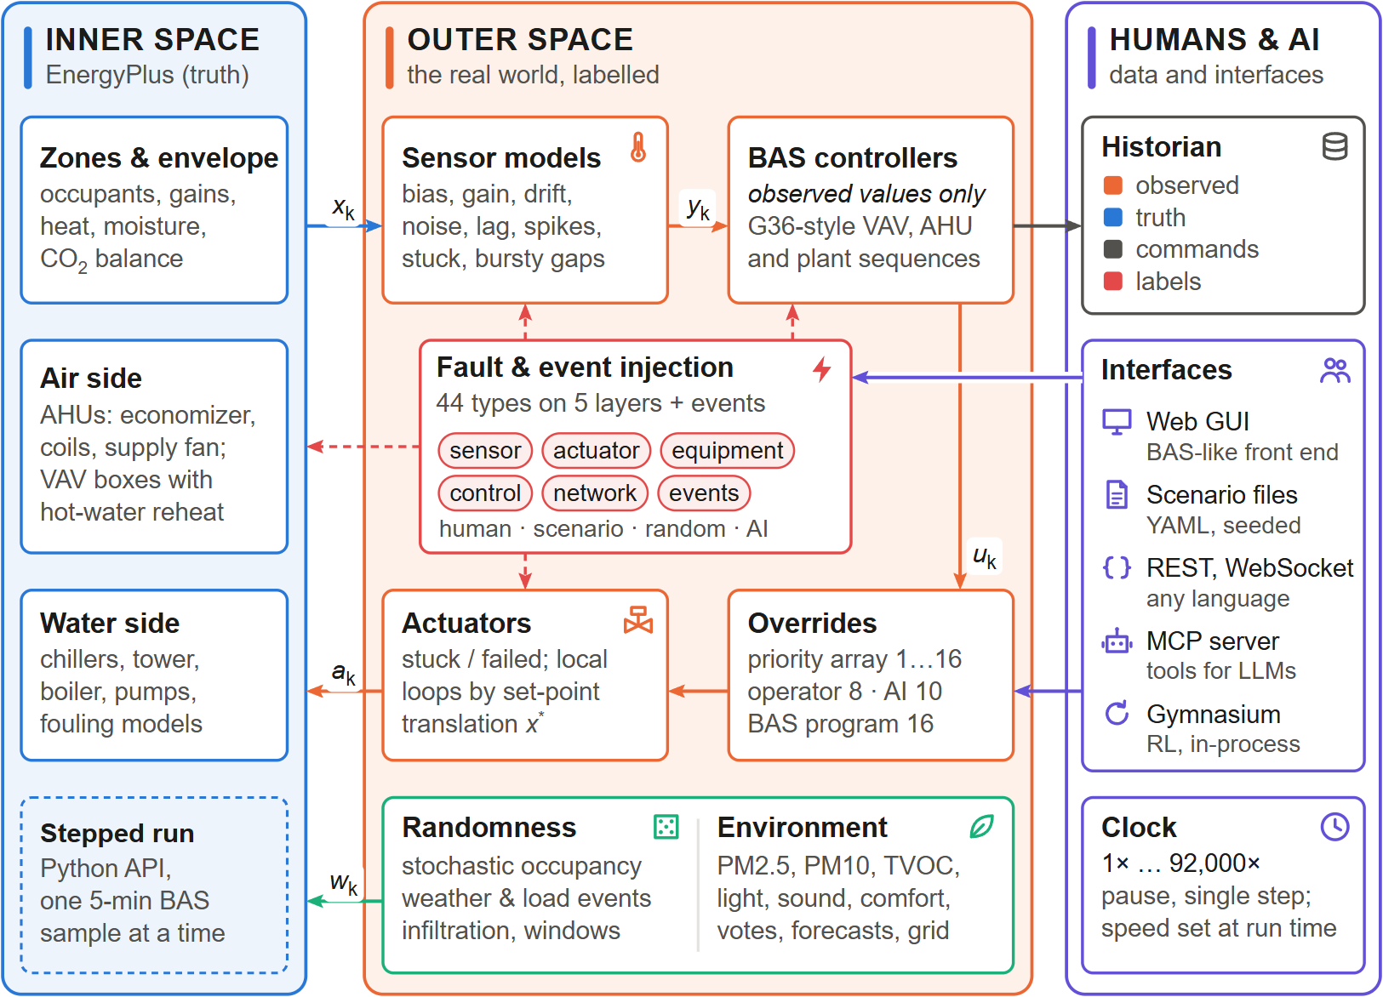
- Fig. 1

- ×

. Architecture of EmuBAS. The inner space (left) is an EnergyPlus model advanced one 5-min BAS sample at a time. The outer space (centre) measures it through sensor models (truth $x_{k}$ →to observed $y_{k}$), controls it with BAS sequences that see only observed values, resolves priority overrides ($u_{k}$) and actuates it through actuator models and local-loop emulation ($a_{k}$), while real-world randomness and the environment layer act on the physics ($w_{k}$). Fault and event injection (dashed red) acts on sensors, controllers, actuators and the EnergyPlus physics. People and AI agents (right) interact through five interfaces; the historian records observed values, truth, commands and labels.
The contributions are:
- A formal inner/outer-space architecture for real-world BAS emulation, with mathematically defined sensor, actuator, occupancy and fault models (44 types) and a complete labelling scheme;
- A local-loop emulation by set-point translation that propagates sensor errors physically through control loops solved inside EnergyPlus;
- A generic BAS-ization procedure that converts EnergyPlus models into emulators with a semantic point list (Project Haystack [22], Brick [23]), an availability tier for every point and an extended indoor and outdoor environment;
- An open-source implementation with a BAS-like web interface, time control from real time to 92,000 times real time, and five interfaces for people and AI agents (web GUI, scenario files, REST, Model Context Protocol [24] and Gymnasium [25]); and
- A case study on the DOE reference large office [26] with eight experiments, and an analysis of eighteen uses in research, education, workforce training and industry practice.
Section 2 reviews related work, Section 3 presents the method, Section 4 the case study and Section 5 the experiments; Section 6 discusses uses and limitations and Section 7 concludes. Appendices A–F give the model details, additional figures and the complete list of uses.

Related work
Control test beds. Co-simulation of building models with external controllers dates back to BCVTB [27]. BOPTEST [28] standardised the evaluation of advanced control with high-fidelity Modelica emulators [29], a REST API, baseline controllers and key performance indicators, and the Advanced Controls Test Bed [30] connects Spawn-of-EnergyPlus models to external controllers. Energym [31], Sinergym [32] and CityLearn [33] add Gym-style interfaces [34] for learning-based control. These frameworks benchmark controllers in reproducible conditions; they expose a selected set of observations and inputs, treat measurements as exact and offer no library of faults that can be injected during operation. Reviews of data-driven control for buildings [4,9] and of control in the real world [10] name exactly these missing ingredients: noisy and partial observations, delays, safety constraints, non-stationarity and unexpected events.
Fault modelling and FDD data. Fault modelling for HVAC has been reviewed in [35], and EnergyPlus supports a set of operational faults (sensor offsets, fouling of coils, chillers, boilers, towers and filters, thermostat offsets) [36]. ASHRAE RP-1312 [37] and the LBNL dataset [38] provide labelled faulted and fault-free data, and a unified taxonomy organises HVAC faults [39]. These datasets are invaluable but static: an algorithm cannot interact with them, inject new faults or close the loop. FDD reviews [2,3] repeatedly identify the lack of ground truth and of test environments with realistic sensor errors as a barrier to deployment.
Semantics and agents. Brick [23] and Project Haystack [22] provide semantic models for BAS points and enable portable analytics. LLM agents that use tools through the Model Context Protocol [24] create a new class of building applications whose evaluation requires an interactive, semantically described BAS with ground truth.
Simulators for education and training. Full-scope training simulators are mandatory in nuclear power [16] and standard in aviation. In buildings, a hybrid simulator that connected a real-time HVAC simulation to a real controller supported a community-college curriculum on control configuration and troubleshooting [18], and a video game introduces a university course on HVAC control [19]. These tools teach control principles on simplified systems; none reproduces the point list, graphics, alarms and failure modes of a commercial BAS on a full building with labelled faults.
Gap. EmuBAS reuses the physics of EnergyPlus and, like the control test beds, lets external programs interact with the building in closed loop at every time step. Its object of emulation, however, is the BAS as a whole—point list, controllers, alarms, historian and operator overrides—embedded in a labelled real-world layer, interactive at any speed, open to fault injection by people and AI, and obtained automatically from existing EnergyPlus models.

Method

Inner and outer space
Let xkxk be the physical state of the building at BAS sample $k$ as computed by EnergyPlusyk, yk the values reported by the BAS, ukuk the controller outputs and akak the values written to EnergyPlus actuators. With $θ(t)$ the parameters of the outer space, which injections modify, one BAS sample is
yk =Sxk;θS(tk), uk=Cyk;θC(tk),ak =Auk,xk;θA(tk), xk+1=Exk,ak,wk;θE(tk) (1yk&=Sxk;θS(tk),&uk&=Cyk;θC(tk), (1)ak&=Auk,xk;θA(tk),&xk+1&=Exk,ak,wk;θE(tk), (2)
)
where $S$ is the sensor layer, ykyk the BAS present values (last valid sample of yy), $C$ the BAS control program, $A$ the actuator layer including local-loop emulation, $E$ one EnergyPlus time step with weather and stochastic disturbances wkwk, and $θ_{E}$ the physical fault parameters. The controller never sees xkxk, and all quantities (xkxk,ykyk,uuk,θ(tk)) are recorded.

Step-wise co-simulation and time control
EnergyPlus runs in a worker thread. At the start of every zone time step an API callback reads all output variables, meters and internal variables, calls the outer space and writes the returned actuator values; EnergyPlus is suspended while the outer space computes, so the simulation is truly stepped. Values read at the start of step $k$ refer to the end of step $k-1$, the instant at which a BAS samples. The pace is set by a speed factor $s$Δt: the target wall-clock time of sample $k$ is $τ_{k}=τ_{k-1}+Δt/s$, and the runner sleeps τkin short slices so that speed changes, pause and single-step requests from the GUI or API take effect immediately; $s=∞$ runs as fast as possible. Requests from all interfaces are queued and applied at a fixed point Δtof the sample, so an injection or override issued at any wall-clock time takes effect at a well-defined sample and interactive sessions are reproducible. Appendix A (Fig. 19) details the sequence of one sample.

kΔt

BAS-ization of an EnergyPlus model
A BAS-ready emulator is obtained from any EnergyPlus model by seven generic stages (Fig. 2). The HVAC topology is discovered from EnergyPlus’ own connection objects, giving zones, terminal units, air handling units (AHUs) with their outdoor-air system, coils and fan, and plant loops with chillers, boilers, towers and pumps. Every quantity the BAS writes is bound to a dedicated command schedule, physical faults are hooked to EnergyPlus fault models, and the native schedules are extracted so that the default BAS program reproduces the native operation of the source model. Appendix A gives the details and the transformations (Table 2).
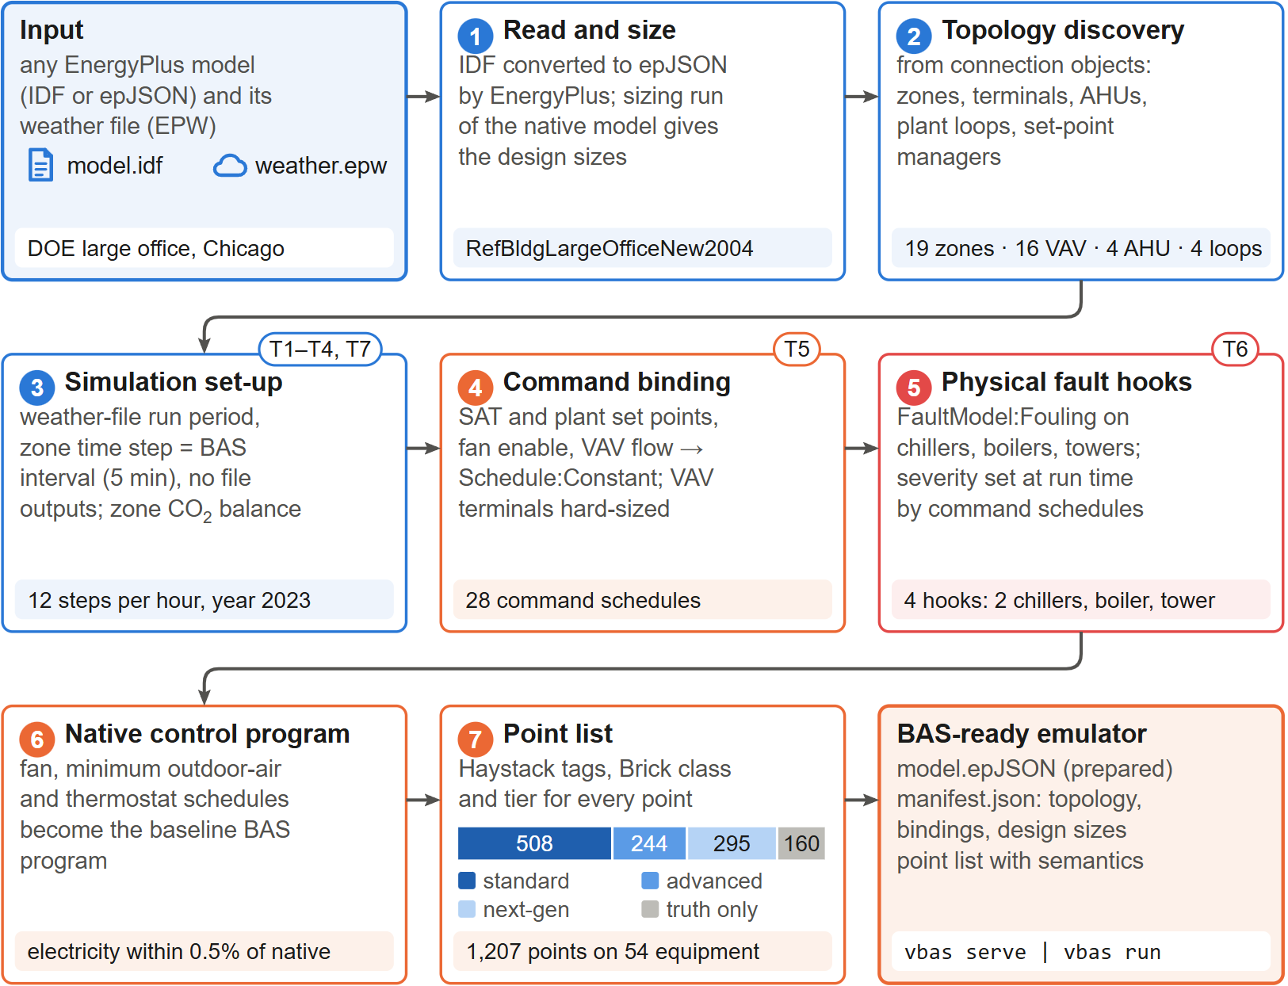
Fig. 2
. BAS-ization of an EnergyPlus model. Seven generic stages convert any EnergyPlus model and weather file into a BAS-ready emulator; tags T1–T7 refer to the transformations of Appendix A, and the shaded strips give the results for the DOE large office. The stacked bar in stage 7 shows the availability tiers of the 1207 points.

=
→
​2
From the topology a BAS point list is generated: for every piece of equipment, the points a commercial BAS would expose (Table 3), each with a stable identifier (AHU-2/SA-T), unit, kind, sensor class, Haystack tags and a Brick class. Sensor points are bound to EnergyPlus variables, meters or derived expressions; quantities that EnergyPlus does not resolve, such as duct static and loop differential pressures, chiller refrigerant pressures, boiler flue temperature and fan vibration, come from documented surrogate models. Quantities that a BAS cannot measure but that are useful as labels (true occupant count, coil loads, COP, true outdoor-air fraction) are recorded as ground-truth-only points.
Every point carries an availability tier. Standard points are those of the Guideline 36 point lists [1], vendor chiller integrations and utility meters; they include the zone temperature, CO₂ and occupancy sensors through which a typical BAS already observes the indoor environment. Advanced points are found in well-instrumented BAS (actuator feedback, air and water flow meters, sub-meters, refrigerant-side chiller data​2). Next-generation points are rarely installed today but valuable for analytics and AI (people counters, particle and VOC monitors, comfort stations, coil energy meters, vibration, forecasts, tariff, grid carbon intensity, demand-response signals, occupant votes and complaints). BAS-calculated points (run-hours, kW/ton, demand, outdoor-air fraction, Guideline 36 requests) are computed from observed values, so sensor errors propagate into them as in a real BAS. A scenario can restrict the exposed points to a set of tiers, for example to emulate a typical BAS of today while keeping the full ground truth.
In the case-study building only 508 of the 1207 points (42%) are standard (Fig. 3): terminal points are mostly standard, whereas the zone points are dominated by next-generation sensing.
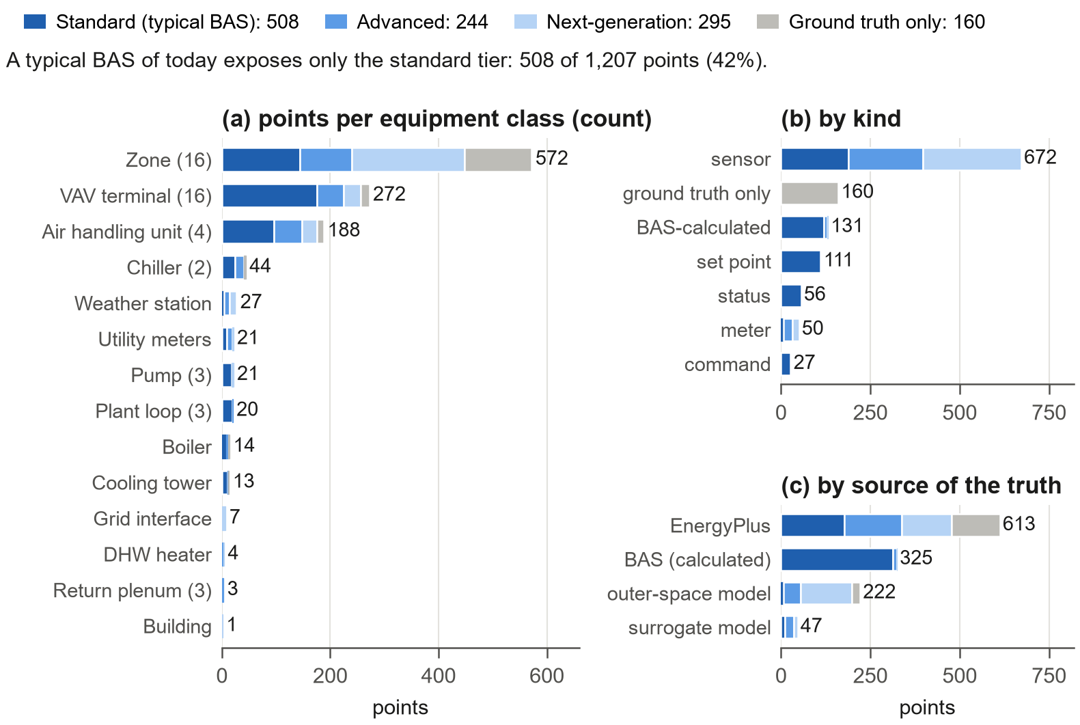
Fig. 3
. BAS point list of the large office (1207 points) coloured by availability tier: (a) per equipment class (number of units in brackets), (b) by kind and (c) by the source of the true value. A typical BAS of today exposes only the standard tier (42%).

ΔT

Sensors, actuators and local-loop emulation
For a physical quantity $x_{k}$ the sensor model returns
yk=clipδ round(1+g) xk+b+dk+σnεk+Bkσsηkδ (2xk&=xk-1+Δtτ+Δtxk-xk-1, (3)dk&=dk-1+r Δt+ϑ(μd-dk-1) Δt+σdΔt ξk, (4)zk&=(1+g) xk+b+dk+σnεk+Bkσsηk, (5)yk&=clip​δ round(zk/δ), ymin, ymax, (6)
)
with first-order sensor dynamics τxk, installation gain error g and bias b, a drift dk composed of a linear rate rand an Ornstein–Uhlenbeck component [40]gb, white noise, Bernoulli spikes Bk∼Bern(ps), quantisation $δ$ and range limits. A stuck sensor returns the value at the stuck instant, and missing samples follow a two-state Gilbert–Elliott chain [41,42]pgbpbg that produces realistic bursts

Explicit BAS outputs (VAV air-flow commands, outdoor-air damper position, fan start and stop) pass through actuator models that can be stuck, failed or overridden. Some loops, however, are closed inside EnergyPlus by ideal local controllers: the reheat valve to the zone heating set point, the AHU coil valves to the supply-air set point, and chillers and boilers to their leaving-water temperature. A real local loop drives its measured value to the set point $r$; with the sensor map $y=(1+g)x+b$, the steady state of a loop with integral action satisfies $(1+g)x^{*}+b=r$, hence
$x^{*}=\frac{r-b}{1+g}$ (3. (7))
EmuBAS therefore hands $x^{*}$ instead of $r$ to the ideal EnergyPlus controller (set-point translation, Fig. 4). A stuck or spoofed vreading winds the integral action up and saturates the actuatorx*=xmaxv<r, and xminan unavailable reading holds the last output. With Eq. (3) every sensor fault propagates physically, including through loops that the BAS does not compute explicitly. The VAV box flow loop is emulated in the same way, and the resulting flow fraction is written to the terminal’s minimum-flow schedule so that EnergyPlus delivers exactly the commanded flow.
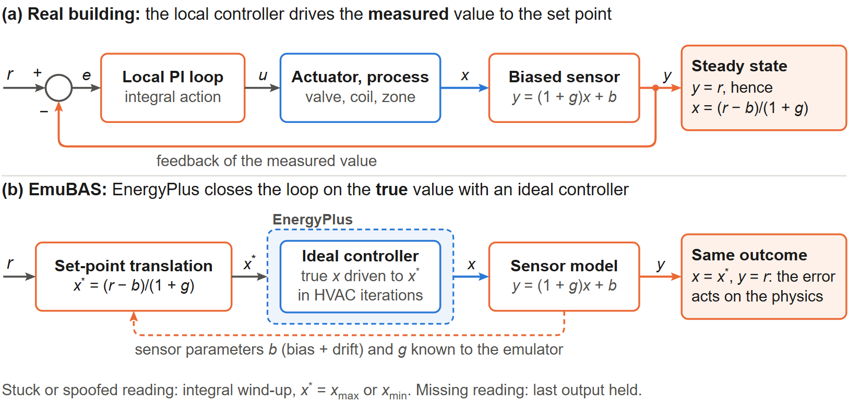
Fig. 4
. Local-loop emulation by set-point translation. (a) In a real building, a local loop with integral action drives the biased reading $y$ to the set point $r$, so the true value settles at $x=(r-b)/(1+g)$. (b) EnergyPlus solves the loop with an ideal controller on the true value; handing it the translated set point $x^{*}$ reproduces the same physical outcome, so sensor faults propagate into the physics.

Real-world randomness and extended environment
Each zone with $N$ design occupants follows the inhomogeneous Markov model of Page et al. [43], driven by its EnergyPlus occupancy schedule P(t)and a daily attendance factorad∼U(amin,1)
T01=μ-1μ+1Pk+Pk+1, T11=Pk-1Pkμ-1μ+1Pk+Pk+1+Pk+1Pk,nk+1=Bin(nk,T11)+Bin(N-nk,T01),
μ; the count is written to the EnergyPlus People actuator, so occupants affect heat gains and ​2CO₂, while the BAS observes them only through PIR sensors with false readings

. Weather perturbations (heat waves, cold snaps, cloud cover) act on the EnergyPlus weather actuators, and plug and lighting load changes, window opening, meetings, holidays and outdoor ​2CO₂ changes complete the event library (Appendix B).

EnergyPlus solves the heat, moisture and ​2CO₂ balances. Quantities that it does not model, but that occupants experience and next-generation BAS measure, are computed in the outer space from the EnergyPlus state at every step, so they remain consistent with the simulated air flows, occupants, lighting power and solar gains (Fig. 5). Particles and VOC follow a well-mixed mass balance of each zone with volume V, supplied with Qs by its terminal and $Q_{i}$ by infiltration:
VdCdt=QsCs+P QiCo+S-Qs+Qi+kVC, Cs=(1-η)xOACo+(1-xOA) Cret (4VQs)

VdCdt&=QsCs+P QiCo+S-(Qs+Qi+kV) C, (10)Cs&=(1-η)xOACo+(1-xOA) Cret,
with outdoor concentration $C_{o}$, penetration factor $P$, deposition rate $k$, indoor source $S$, the AHU outdoor-air fraction $x_{OA}$ from EnergyPlus, filter efficiency $η$ by MERV class [44] and the flow-weighted return concentration CretCret. Eq. (4) is integrated exactly over each step for PM2.5, the coarse fraction PM2.5–10 and TVOC; wildfire_smoke, indoor_pollutant_source and filter_bypass injections act on $C_{o}$, $S$ and $η$. Illuminance, sound, comfort indices (PMV and PPD [45]), occupant votes and complaints, an hourly-issued 48-h weather forecast, a time-of-use tariff, a marginal grid carbon intensity and ​2demand-response events complete the layer; Appendix B gives their models. These models are deliberately simple and documented; they make the corresponding points behave plausibly and causally, not reproduce a particular building.
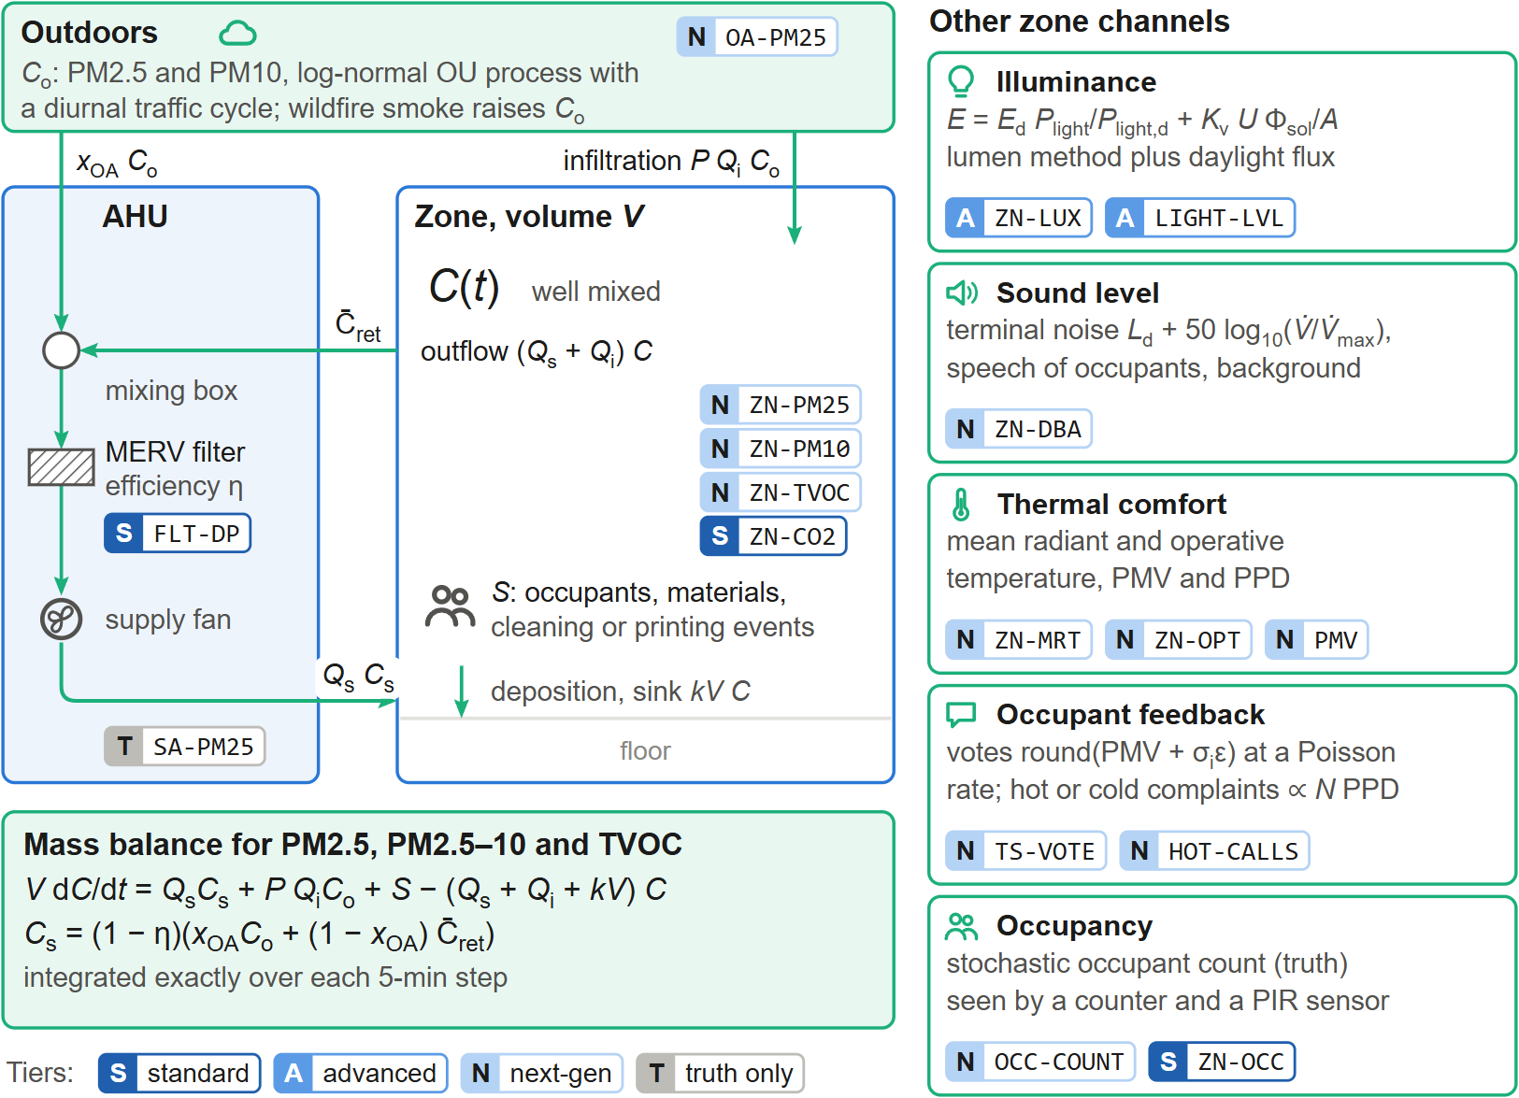
Fig. 5
. Extended environment of one zone. Particles and TVOC follow a well-mixed mass balance driven by EnergyPlus air flows: supply air through the AHU’s MERV filter, infiltration from outdoors (where wildfire smoke raises $C_{o}$), indoor sources and deposition. Illuminance, sound, comfort, occupant feedback and occupancy are derived from the same EnergyPlus state. Badges give the point identifier and its availability tier (S standard, A advanced, N next-generation, T ground truth only).

round(PMV+σiε)N PPD

±σ(h)σ(h)

μ​3

Faults and injections
All abnormal or random conditions are injections of a registered type. An injection has a target (point, equipment, zone or building), start $t_{0}$, optional end $t_{1}$ and a severity profile that modulates one parameter, θ(t)=θ0+s(t) Δθ:
s(t)=0t<t0 or t≥t11step min 1,(t-t0)/Trramp (incipient)1(t-t0) mod P<D Pintermittent (5s(t)=0t<t0 or t≥t11stepmin​1,(t-t0)/Trramp (incipient)1​((t-t0) mod P)<D Pintermittent
θ(t)=θ0+s(t) Δθ)
Fig. 6 shows the library. Sensor faults apply to any sensor point; actuator faults stick dampers and valves or fail the supply fan; equipment faults degrade chillers, boilers, towers, filters and fans or trip plant equipment, acting inside EnergyPlus through its fault models and actuators; control faults corrupt schedules, tuning, economizer and reset logic or freeze a controller; network faults take a controller off-line or stop the historian. Events are the randomness of a real building rather than faults. New types are registered with a decorator and immediately appear in the GUI (Appendix E, Fig. 25), the REST catalogue and the MCP tools. A random fault generator draws arrivals from a Poisson processλ and samples type, target, magnitude and duration from configurable distributions.
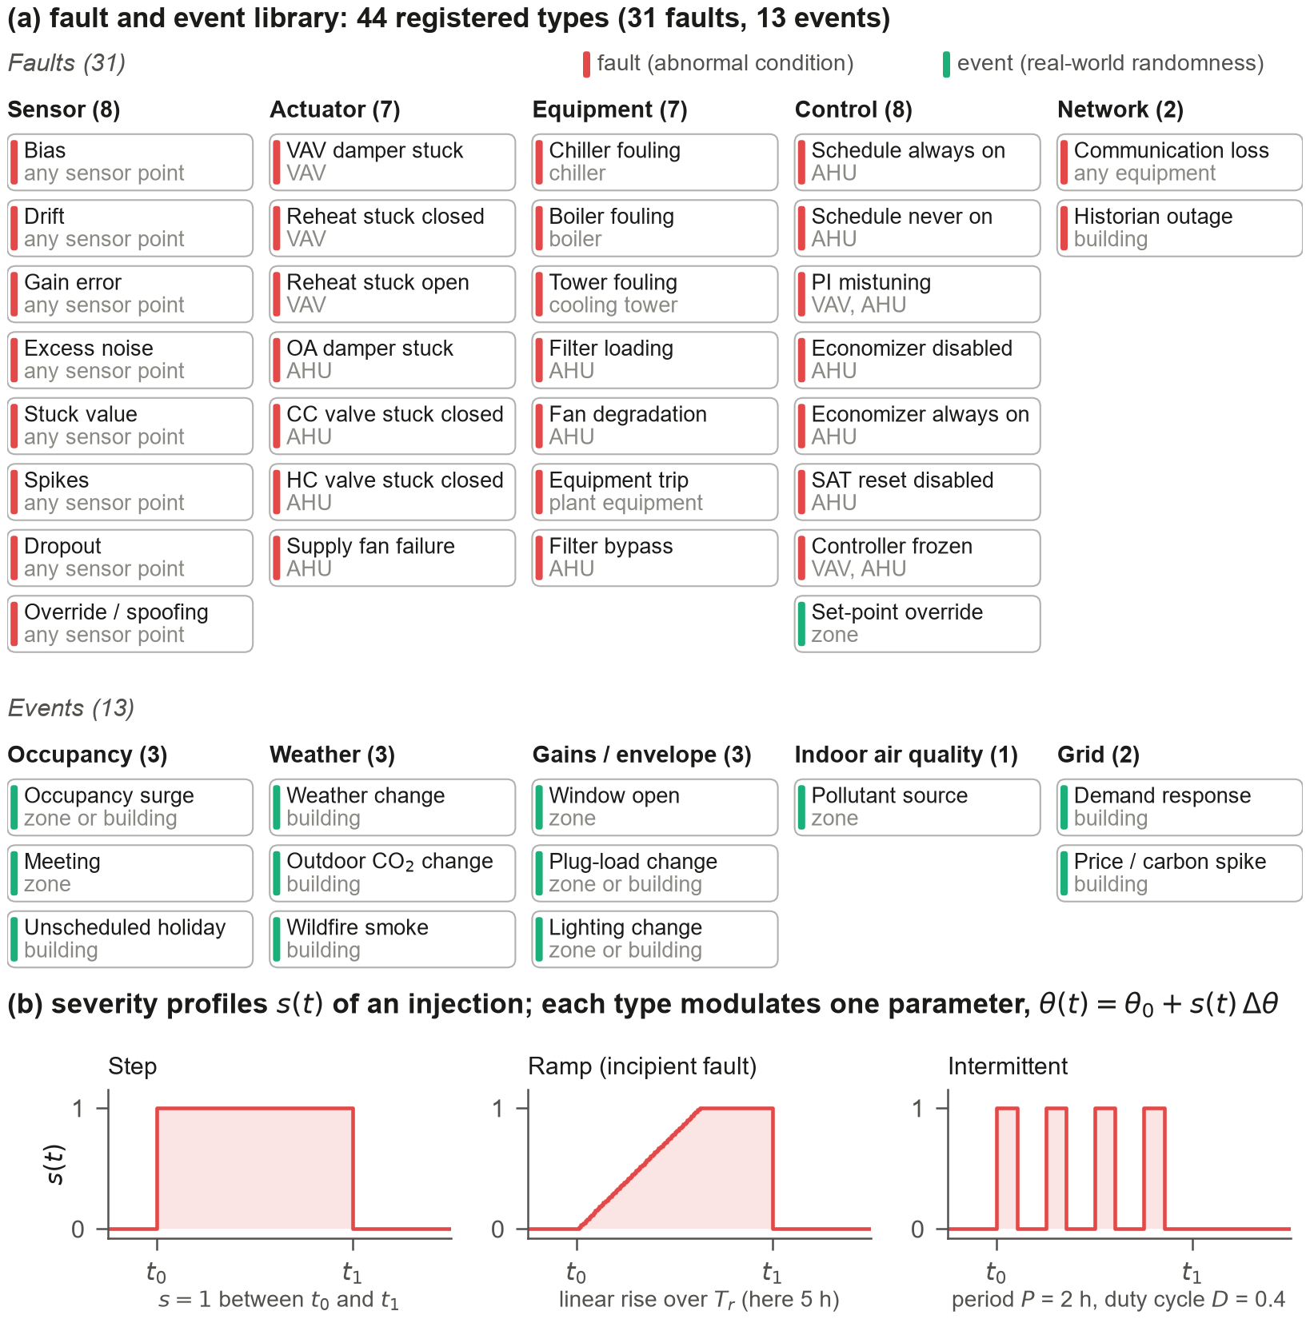
Fig. 6
.

(a) Fault and event library: 44 registered injection types, 31 faults on five layers and 13 events, each with its target type. Every type has a defining equation and typed parameters, and every injection is labelled with its source (person, AI, scenario, random). (b) Severity profiles s(t)): step, ramp over $T_{r}$ (incipient faults) and intermittent with period $P$ and duty cycle $D$.

BAS control program, labels and interfaces
The BAS control program acts on present values only. It comprises occupancy scheduling, VAV cooling and heating loops, AHU fan, supply-air temperature, duct static pressure and economizer control, and plant set points (Appendix C). A baseline profile reproduces the native controls of the source model and is used for verification; a g36 profile implements trim-and-respond resets inspired by Guideline 36 [1]. Any software point can be overridden through a BACnet-like 16-level priority array (operator 8, AI agents 10, BAS program 16), and a rule-based alarm engine raises alarms from observed values, so that sensor faults can cause false alarms or mask real ones.

A run produces synchronised tables of observed values (the BAS trend log with gaps), truth, commands and per-sample label bit masks, the severity of every active injection at every sample, the injection definitions, the sensor installation parameters, the alarm history and the metadata; the exact sensor error of every sample is $y_{k}-x_{k}$ (Appendix D, Fig. 23).
People and programs reach the emulator through five interfaces (Fig. 7): scenario files, a REST/WebSocket API, an MCP server that exposes BAS tools to LLM agents [24], a Gymnasium environment [25] for learning-based and other programmatic controllers, and a

web GUI that mimics a commercial BAS front end (Fig. 8). All writes meet in the one priority array, so an operator at priority 8 overrides an AI agent at priority 10, which overrides the BAS program. A global switch in the GUI reveals the EnergyPlus truth next to every observed value. In the staged session of Fig. 8, an operator and an AI agent had injected eleven faults and events; the operator sees a busy alarm banner and plausible zone temperatures, and only the truth layer reveals that the core zones of ten floors are overcooled by almost 4 K (callout 8) and that a supply-air sensor reads 2.7 K high (callout 10). Further GUI views are in Appendix E.
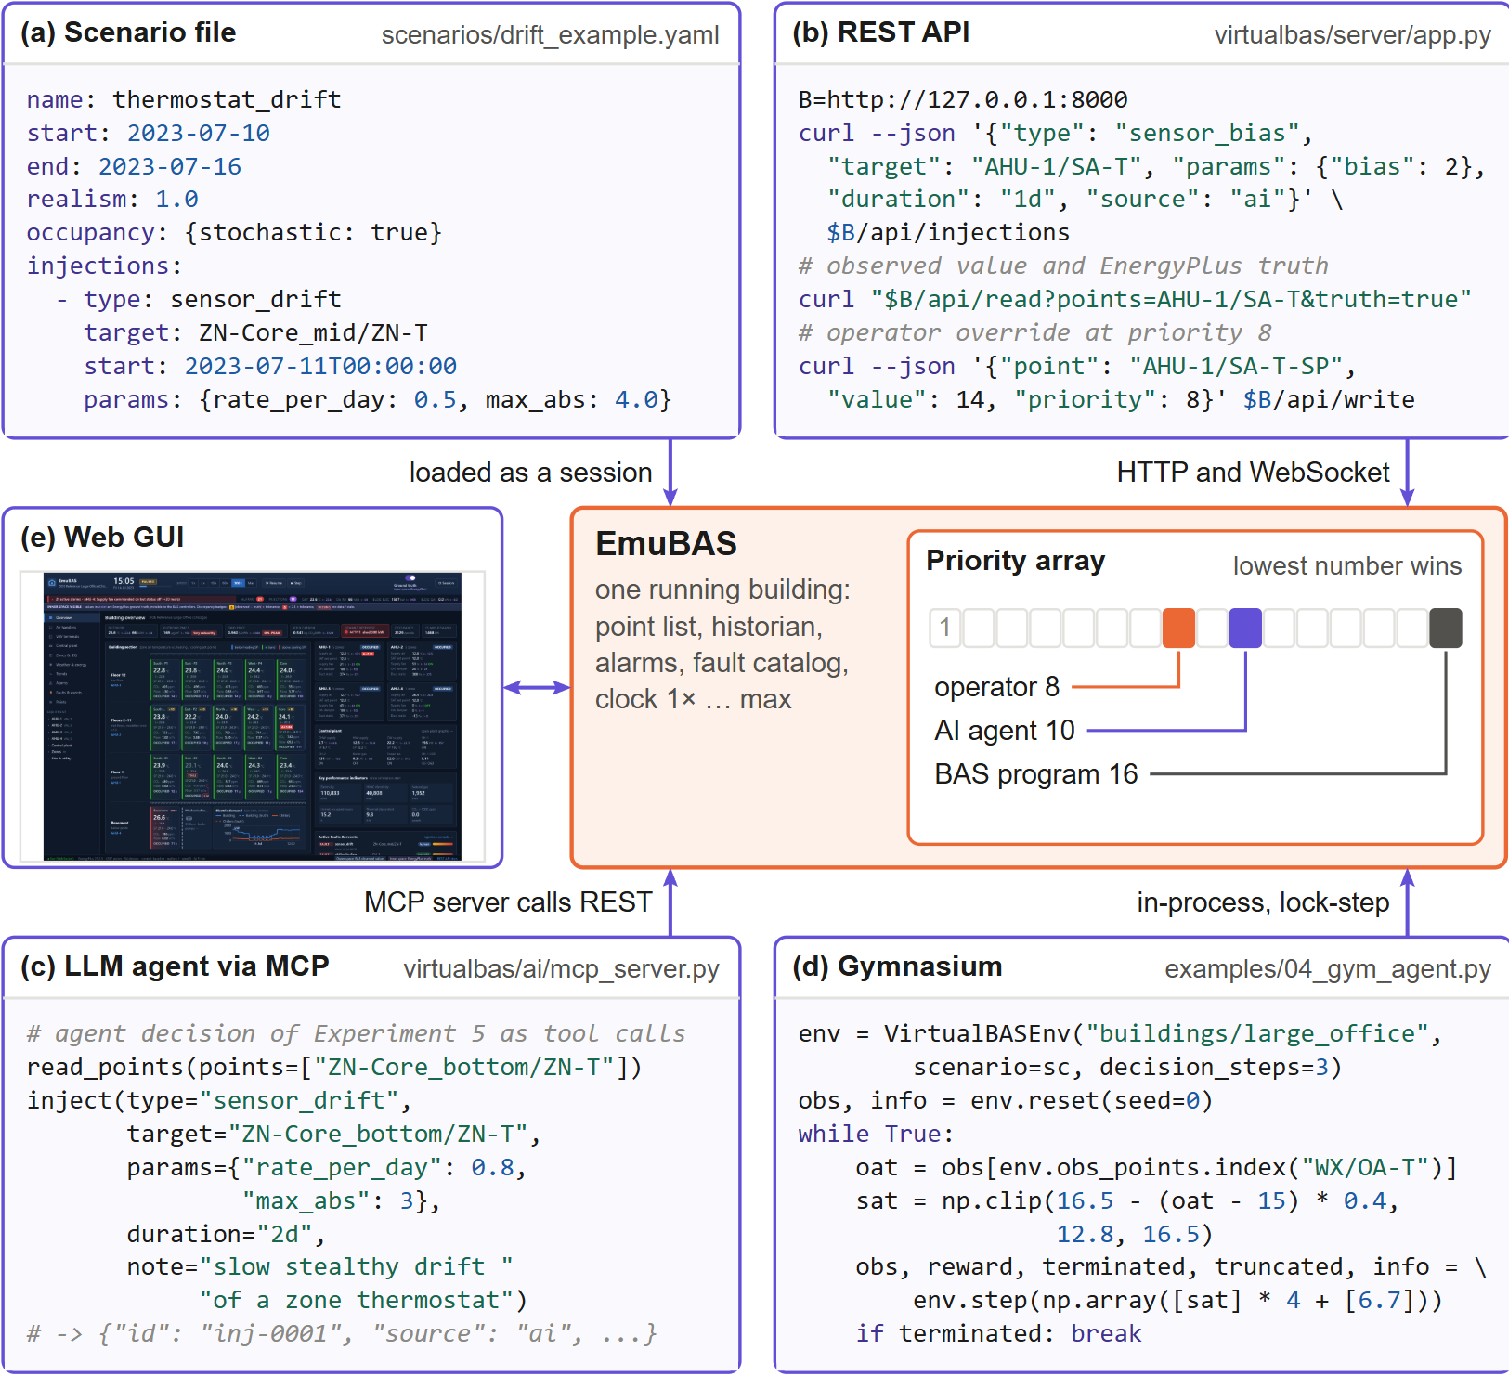
Fig. 7
. One building, five ways in. (a) Scenario file, (b) REST API, (c) an LLM agent through the MCP server (the first decision of the agent of Experiment 5 expressed as MCP tool calls), (d) a Gymnasium control loop and (e) the web GUI all act on the same running emulator. Writes from any interface enter a BACnet-like priority array in which the lowest number wins (operator 8, AI agents 10, BAS program 16).
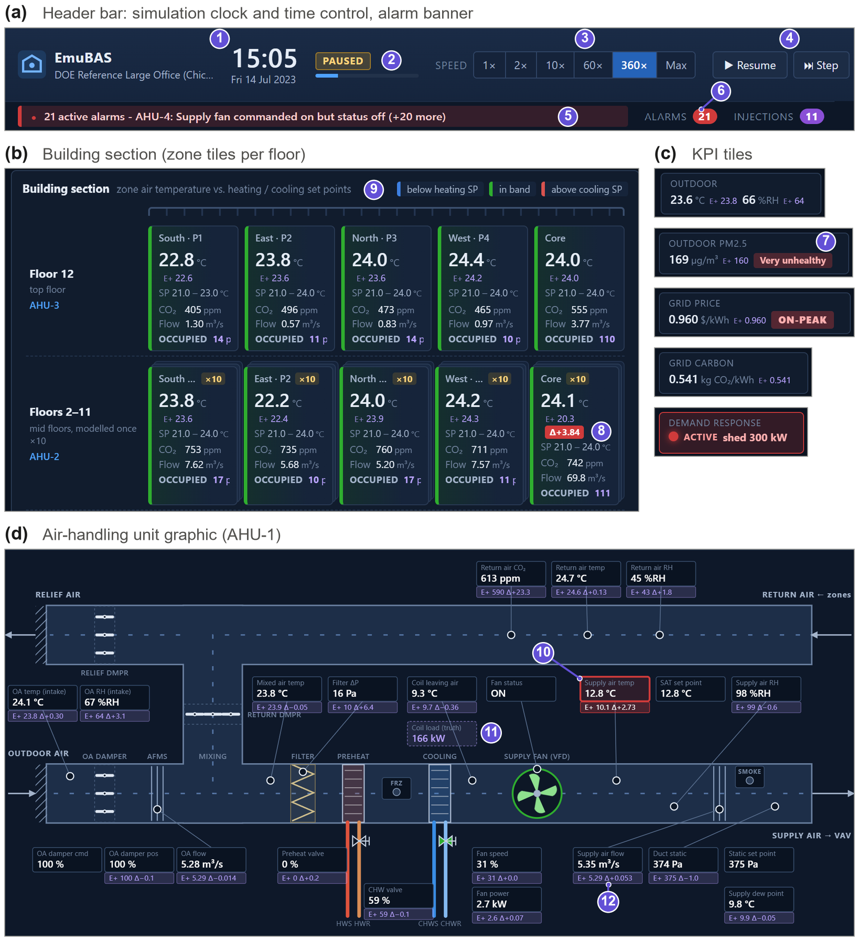
Fig. 8
. The EmuBAS operator workstation with the ground-truth layer switched on. (a) Header with the simulation clock and time control (1–4) and the alarm banner and counters (5, 6); (b) building section with one tile per zone and floor; (c) KPI tiles for outdoor air, outdoor PM2.5, tariff, grid carbon and demand response; (d) AHU graphic with equipment-level points. Every observed value carries its EnergyPlus truth (E+) and a discrepancy badge when the two disagree: the drifting Core_mid thermostat reads 24.1​∘ °C while the zone is at 20.3​∘ °C (8), and an AI-injected +2.5 K supply-air sensor bias is invisible to the controller but visible against the truth (10). Truth-only quantities have dashed boxes (11).

​∘

Case study
The DOE commercial reference large office (new construction, ASHRAE 90.1-2004, Chicago) [26] distributed with EnergyPlus 23.2 is used (Fig. 9). The 12-storey, ​246,320 m² building is modelled with 19 zones (basement, ground, a middle floor representing ten floors through a zone multiplier, and top floor, each with four perimeter and one core zone, plus plenums), four VAV AHUs with economizers, chilled- and hot-water coils and variable-speed fans, 16 VAV boxes with hot-water reheat, two water-cooled chillers, a cooling tower, a gas boiler and three pumps. BAS-ization with a 5-min sampling interval yields 1207 points on 54 pieces of equipment (722 sensor and meter points, 325 software points and 160 ground-truth-only points). The Chicago TMY3 weather file and the calendar year 2023 are used; all experiments ran on a Windows 11 laptop with EnergyPlus 23.2 and Python 3.12.
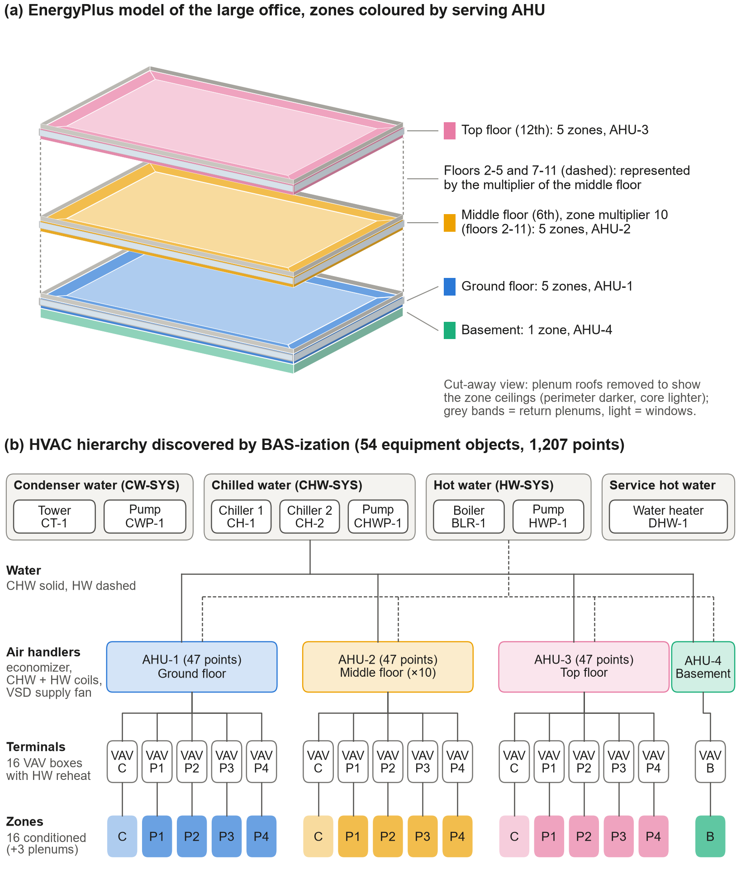
Fig. 9
. Case-study building. (a) EnergyPlus geometry of the DOE reference large office (cut-away view, plenum roofs removed), zones coloured by the AHU that serves them; the middle floor is modelled once with zone multiplier 10 and represents floors 2–11. (b) HVAC hierarchy discovered automatically by BAS-ization: condenser, chilled-water, hot-water and service-hot-water loops, four VAV AHUs, 16 VAV terminals with hot-water reheat and 16 conditioned zones (C core, P1–P4 perimeter, B basement).

Experiments and results

Experiment 1: verification against native EnergyPlus
The emulator must not distort the physics. A full year was simulated natively in EnergyPlus and with EmuBAS using ideal sensors, deterministic occupancy and the baseline control profile (Table 1, Fig. 10). Annual electricity agrees within 0.5% (hourly CV(RMSE) 2.8%), natural gas is 5.2% higher and the hourly temperatures of the 16 zones differ by 0.03 K on average; whole-building electricity and gas satisfy the ASHRAE Guideline 14 hourly calibration criteria [46]±. The residual differences have a clear origin: the native model uses ideal controllers solved within EnergyPlus’ HVAC iterations, whereas the BAS controllers are sampled-data controllers acting every 5 min on the previous sample, which matters most at morning start-up and for pump energy. A year took 300 s with EmuBAS versus 35 s for the native batch simulation.
Table 1. Experiment 1: annual energy of native EnergyPlus and EmuBAS (ideal sensors, baseline control profile).
End use | Native (MWh) | EmuBAS (MWh) | Difference (%) | Hourly CV(RMSE)​h (%)
Electricity, total | 5,729 | 5,756 | +0.5 | 2.8
Natural gas, total | 1,580 | 1,663 | +5.2 | 15.0
Cooling (chillers) | 509 | 502 | −1.3 | 13.9
Fans | 178 | 178 | +0.2 | 5.8
Pumps | 258 | 295 | +14.1 | 44.4
Heat rejection | 139 | 136 | −2.3 | 20.7
Heating (boiler) | 1,511 | 1,594 | +5.5 | 15.7
Interior lighting | 1,566 | 1,566 | 0.0 | 0.0
Interior equipment | 2,329 | 2,329 | 0.0 | 0.0
Note: Zone air temperature, mean of 16 zones: MAE 0.029 K, RMSE 0.091 K.
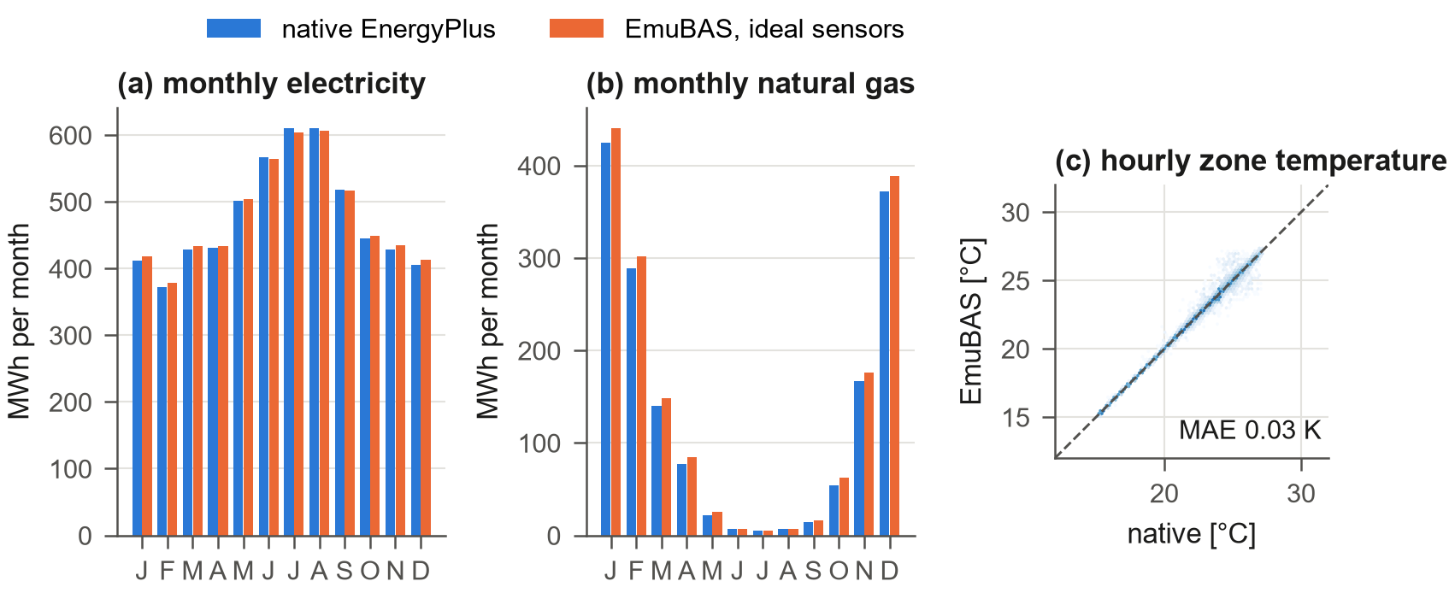
Fig. 10
. Experiment 1: (a) monthly electricity and (b) monthly natural gas of native EnergyPlus and EmuBAS with ideal sensors; (c) hourly zone temperatures of all 16 zones over the year.

Experiment 2: inner/outer-space coupling under sensor drift
The motivating example was simulated for one summer week with realistic sensors and stochastic occupancy: the zone temperature sensor of the core zone of the middle floors (representing ten floors) drifts by +0.5+0.5 K/day from the second day, compared with a fault-free twin run with identical random streams (Fig. 11). The VAV controller keeps the observed temperature at the cooling set point throughout, while the true temperature decreases day by day; at the end of the week the sensor reads 2.8 K above the truth. The controller compensates the apparent overheating with more air: the mean discharge air flow during occupied hours rises by 15% and the building’s HVAC electricity by 4.2%. None of this is visible to an operator looking at the zone temperature trend, and no alarm fires because no observed value leaves its band (Appendix E, Fig. 28, shows the same mechanism in the GUI). The run demonstrates the central mechanism of EmuBAS: an outer-space imperfection produces a wrong control signal, the wrong signal changes the physics, and the change is labelled.​∘​∘-1.6
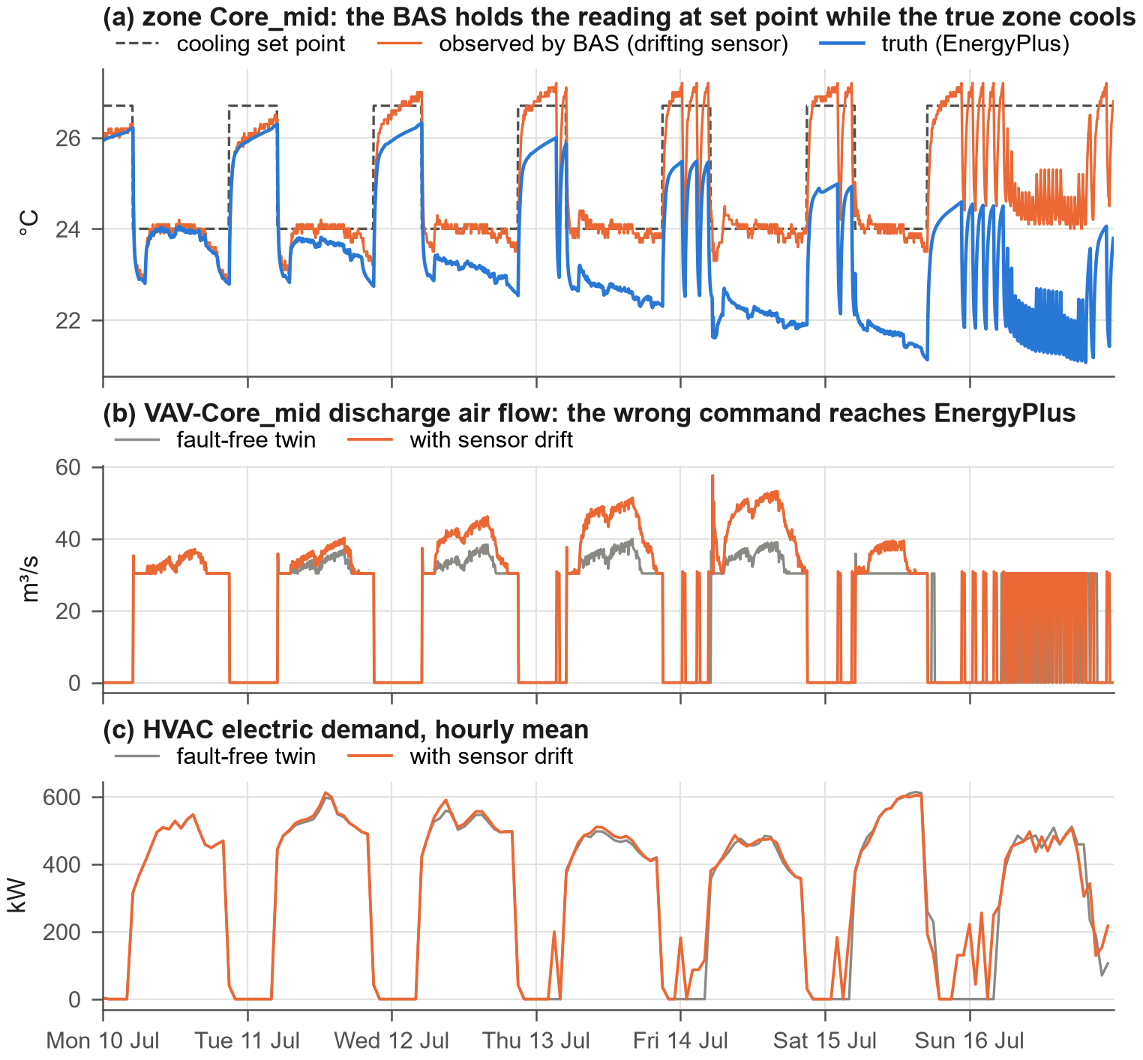
Fig. 11
. Experiment 2: drift of the zone temperature sensor of zone Core_mid. (a) Observed and true zone temperature with the cooling set point; (b) discharge air flow of the VAV box with and without drift; (c) HVAC electric demand.

​∘​∘​∘-1.6

Experiment 3: equipment-level fault impact matrix
Twenty-seven single-fault scenarios covering all layers were each simulated for a summer and a winter week with realistic sensors and stochastic occupancy and compared with the fault-free twin (Fig. 12).⋅±0.5 The matrix shows physically consistent, season-dependent behaviour at equipment level. A stuck-open outdoor-air damper of the main AHU increases winter gas by 157% but has little effect in summer. A leaking reheat valve multiplies summer gas use 16-fold and causes 114 K⋅·h of overheating. A stuck-closed chilled-water valve produces 1210 K⋅·h of summer discomfort and none in winter, and a stuck-closed reheat valve does the opposite (162 K⋅·h in winter). Chiller and tower fouling raise summer electricity by 1.0% and 3.3%, and boiler fouling raises winter gas by 55%. A trip of one of the two chillers reduces summer electricity, because the remaining chiller runs at a more efficient part-load ratio, while discomfort rises at peak load—fault impacts are not always energy penalties. Several faults are silent in one season, an important property of real fault data: labels mark fault presence, while the twin comparison quantifies fault impact.
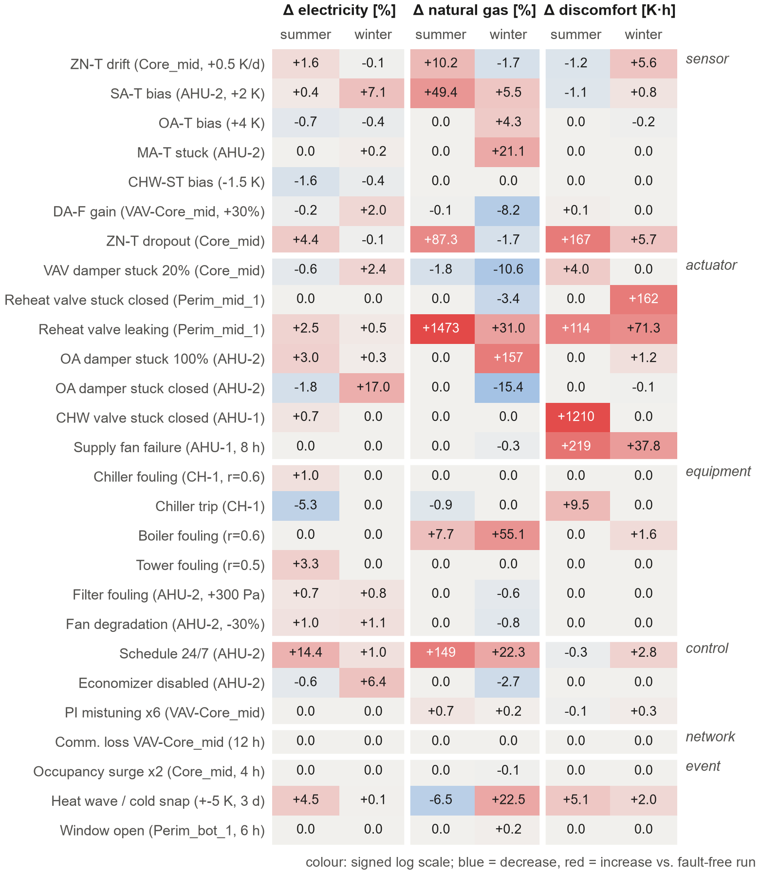
Fig. 12
. Experiment 3: change of electricity, natural gas and discomfort relative to the fault-free twin for 27 single-fault scenarios (one week each, summer and winter), grouped by layer. Colour: signed logarithmic scale.

Experiment 4: labelled data and an FDD benchmark
Two independent datasets were generated with the random fault generator restricted to nine AHU-level fault types at λ=3three faults per week: a training set (April–June, shown in Appendix D, Fig. 23) and a test set (July–August) with different seeds. Hourly features (means and standard deviations of 23 quantities, such as the supply-air temperature error, the mixing-equation residual and fan power per flow) were computed from the observed trend logs only, and labels from the injection severity tables. A random forest [47,48] trained on 8,064 AHU-hours reaches a detection macro-F1 of 0.74 and a diagnosis macro-F1 of 0.24 on 5,376 test AHU-hours (Fig. 13). The difficulty is genuine: the test period lies in a different season, background sensor errors and missing data are present, and several faults are unobservable under the prevailing conditions. EmuBAS thus produces consistently labelled data with controllable difficulty, distribution shift and realistic class imbalance.
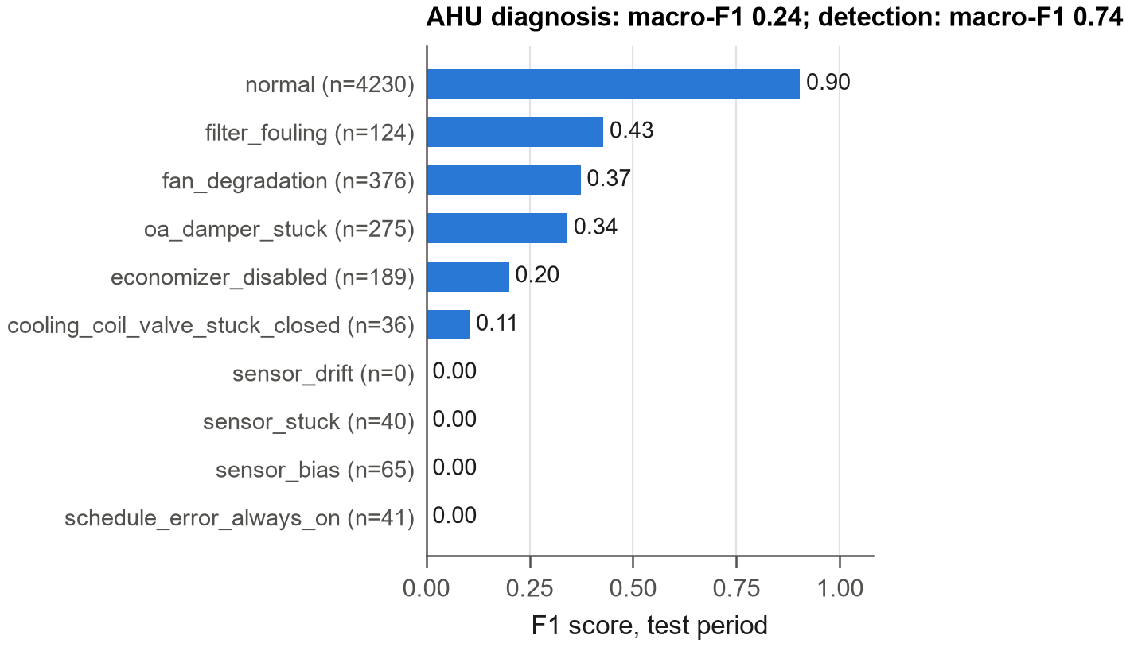
Fig. 13
. Experiment 4: per-class F1 score of the AHU fault diagnosis benchmark on the test period.

Experiment 5: AI agents in the loop
AI fault injection. An autonomous adversarial agent operated the building for six days through the REST API, in lock-step with the simulation. Every six simulated hours it read the BAS like an operator and chose an injection—100% outdoor air on the AHU with the largest fan power in hot weather, an after-hours schedule error in the evening, otherwise a slow thermostat drift—and injected 24 faults, all recorded with their source and the agent’s rationale. The same calls are exposed as MCP tools, so an LLM agent can play this role, for example to stress-test an FDD system.
Robustness of a supervisory controller. A supervisory agent resetting the AHU supply-air and chilled-water set points from the observed outdoor-air temperature was evaluated through the Gymnasium interface in three outer spaces—ideal sensors, realistic sensors, and realistic sensors with a +4+4 K bias of the outdoor-air sensor—for two weeks in the shoulder season and in summer, each against the baseline BAS program in the same outer space (Fig. 14). In the shoulder season the agent saves 5.2% electricity with ideal sensors and 6.4% with realistic sensors, but only 3.3% when the outdoor-air sensor reads 4 K high. At the same time the warmer supply air raises reheat gas use by 21 MWh in two weeks, so that site energy changes by +2.5%; in summer the saving is small (0.3%). An evaluation restricted to electricity and to ideal sensors would have overstated the value of this policy twice—a trade-off that cannot be studied in an idealised environment.
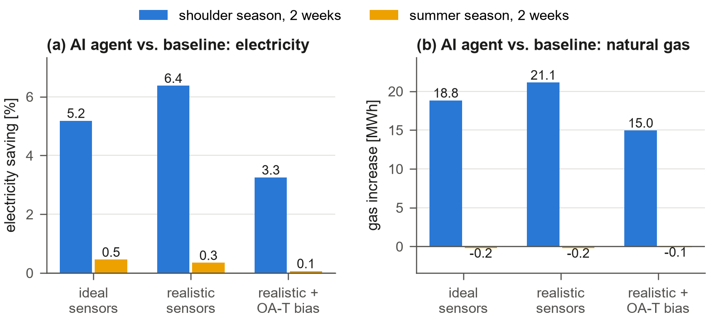
Fig. 14
. Experiment 5: (a) electricity saving and (b) gas increase of a supervisory AI controller relative to the baseline BAS program in three outer spaces: ideal sensors, realistic sensors and realistic sensors with a +4+4 K outdoor-air sensor bias.

Experiment 6: indoor environment under wildfire smoke
A summer week with a 30-h wildfire-smoke episode (outdoor PM2.5 up to 133μ​3 µg/m³) was simulated with the reference MERV 8 filters, with MERV 13 filters, with a filter-bypass fault (60% bypass, no pressure-drop symptom) and with an IEQ-aware sequence that locks the economizers out while outdoor PM2.5 exceeds 35μ​3 µg/m³ (Fig. 15(a)). Because the economizers bring up to 100% outdoor air in this season, the mean indoor concentration peaks at 93μ​3 µg/m³ with MERV 8, 111μ​3 µg/m³ with the bypass fault, 66μ​3 µg/m³ with the lock-out and 45μ​3 µg/m³ with MERV 13; occupied zone-hours above 35μ​3 µg/m³ are 362, 367, 346 and 104. None of this is visible in the standard tier: a typical BAS has no particle sensor, the bypass fault has no pressure-drop symptom, and the lock-out needs the next-generation outdoor PM2.5 point. Panels (b)–(e) show one day of the other environment points of a perimeter zone.
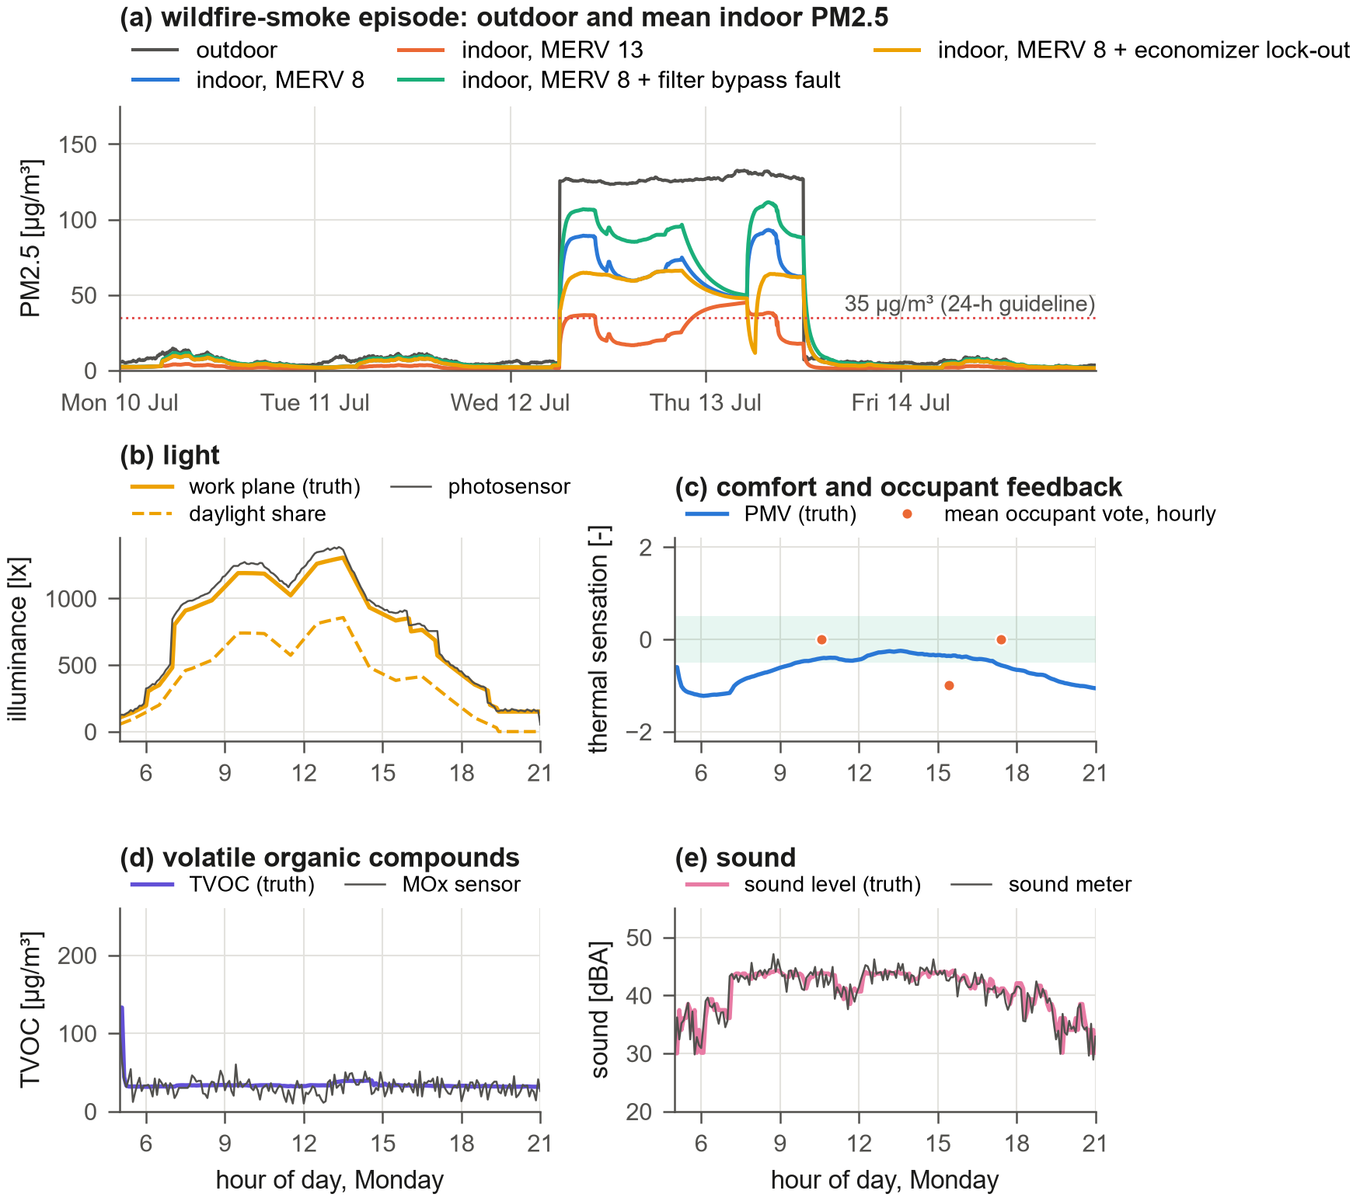
Fig. 15μ​3μ​3μ​3. Experiment 6: (a) outdoor and mean indoor PM2.5 during a wildfire-smoke episode for four filter and

control situations; (b)–(e) one summer day of illuminance, comfort and occupant feedback, TVOC and sound in a perimeter zone (truth and sensor readings).
Because every zone has its own mass balance, the episode can also be resolved in space (Fig. 16). During the day, with the economizers at 100% outdoor air (instant A), the filter is the only barrier: all zones are near the zone mean of 93 µg/m³ with MERV 8 and 38 µg/m³ with MERV 13. At night, with the AHUs off (instant B), the pattern inverts: infiltration carries smoke into the perimeter zones (54–59 µg/m³) whatever the filter, while the core zones stay cleaner, so a filter upgrade alone does not protect perimeter spaces during unoccupied hours. In the GUI the episode appears as an outdoor-air-quality alert next to the tariff, grid signals and forecast (Appendix E, Fig. 27 and Fig. 26).
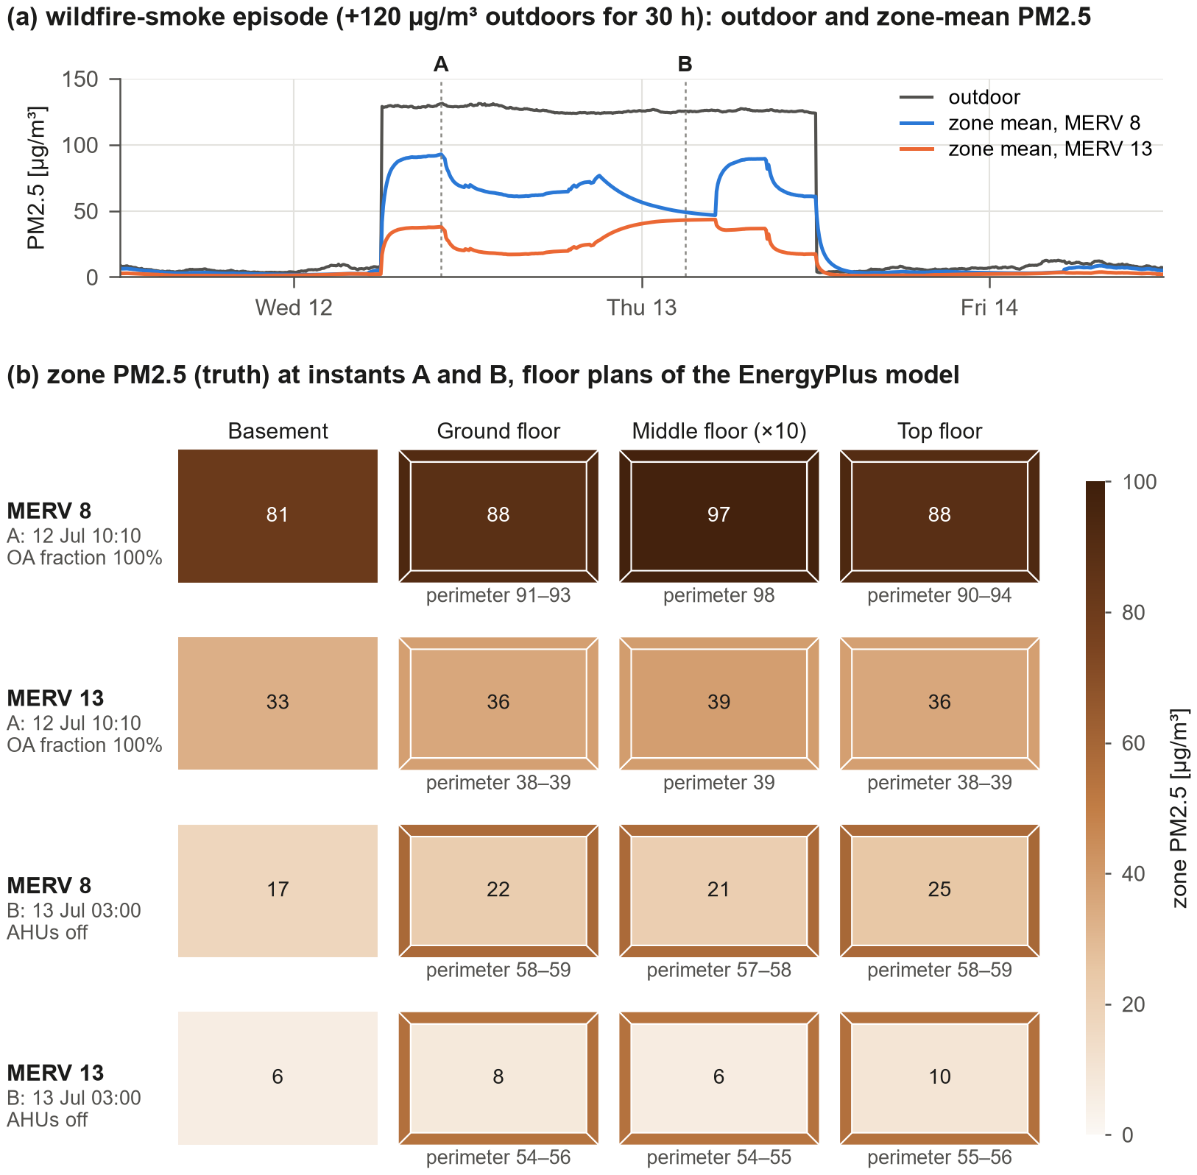
Fig. 16
. Experiment 6 in space. (a) Outdoor and zone-mean PM2.5 during the 30-h smoke episode with MERV 8 and MERV 13 filters; (b) zone PM2.5 (truth) on the floor plans of the EnergyPlus model at instant A (economizers at 100% outdoor air) and instant B (night, AHUs off); perimeter values below each plan.

Experiment 7: time acceleration
The pacing accuracy was measured by setting target speed factors while running (Appendix E, Fig. 29). The achieved speed matches the target within 0.01% for factors from 10 to 3600; at maximum speed one BAS sample takes 3.3 ms, i.e. 92,000 times real time, so one simulated year runs in about 5.0 minutes. Real time ×follows from the same pacing law, and speed changes, pause and single steps take effect at any moment, so the same environment serves real-time interaction with people or deployed agents and fast batch generation of data.

Experiment 8: generality
The BAS-ization procedure was applied without any building-specific code to five DOE reference buildings, from a single-storey small office with five packaged units to a hospital with 55 zones (Fig. 17). All models were converted and simulated for one week. Multi-zone VAV systems with water-based plants (large office, hospital, secondary school) are fully BAS-controlled; the medium office (packaged VAV with DX cooling and electric reheat) and the small office (packaged single-zone units) are monitored completely, and their terminals and thermostats are BAS-controlled while unsupported components keep their native local control. The number of points grows with the number of zones and terminals; the hospital yields 3244 points and still runs at 60 samples per second.
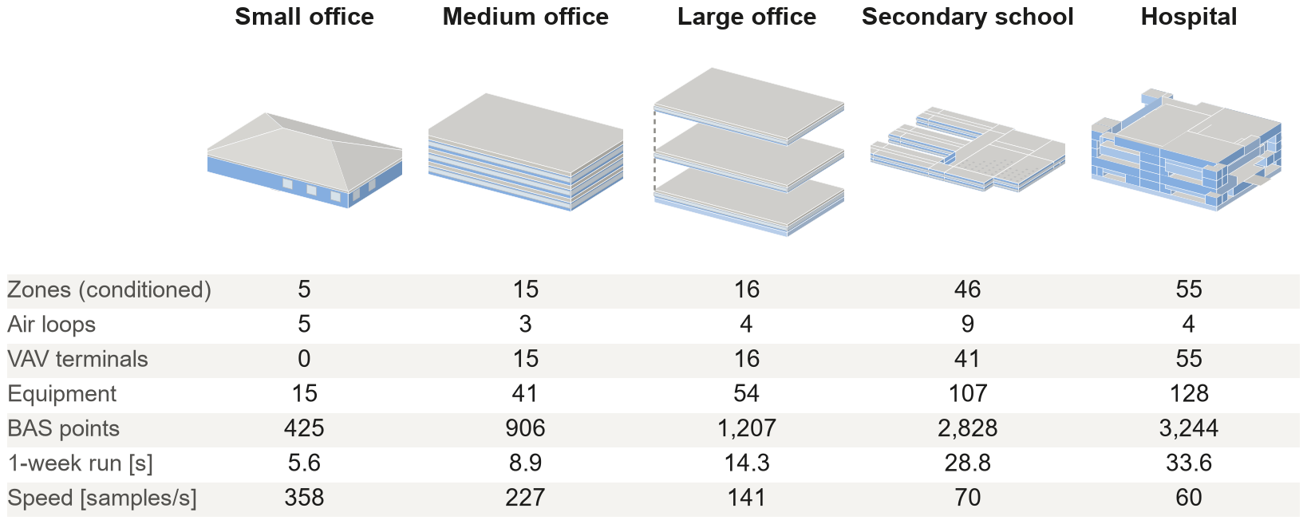
Fig. 17
. Experiment 8: five DOE reference buildings converted automatically (EnergyPlus geometry, not to scale; conditioned zones in blue, windows light) with key figures of the one-week runs.

Discussion

Potential uses and impact
A real BAS is a poor place to learn, experiment or certify: faults cannot be staged, the true state is unknown, mistakes affect occupants and equipment, a year takes a year, and access is restricted by owners, vendors and security policies. EmuBAS removes these barriers at once—it is safe to break, labelled, repeatable through seeded scenarios, faster than real time, free and open, and available for any EnergyPlus model. Fig. 18 maps eighteen uses that follow from these properties onto four areas; Appendix F (Table 4) lists them with their users, the enabling features and the evidence in this paper.

nn
Research and development. FDD developers obtain unlimited labelled data with controllable fault rates, severities, seasons and sensor quality and can test algorithms in closed loop (Experiments 3 and 4). Developers of control sequences, model predictive and learning-based controllers can evaluate them under partial observability, sensor errors, missing data and equipment faults, and quantify robustness by switching the outer space while keeping the physics fixed (Experiment 5). Ambient-AI and LLM agents can be evaluated on operational tasks—diagnosing complaints, finding faults, writing safe overrides—with exact ground truth, or act as adversaries. Because any EnergyPlus model can be converted, the emulator can also produce the large, diverse corpora of labelled, multivariate BAS time series that foundation models for building operation will need; existing synthetic corpora cover whole-building loads only [49]. The point tiers support value-of-information studies (Experiment 6).
Education and workforce development. A course on HVAC systems, controls or building data science can let every student operate the same building, inject a stuck damper or a drifting sensor and see both what the BAS shows and what really happens. For operators, facility managers and technicians the same features become troubleshooting drills: the GUI hides the truth by default, an instructor injects faults or lets the random generator choose them, and the label record serves as the answer key. This brings to building operation the simulator-based training that is standard in aviation and nuclear power [16] and has been limited to prototypes in buildings [18,19]. Commissioning agents can rehearse functional tests, facility managers can practise responses to smoke, heat waves and demand-response events, and reproducible alarm floods support alarm-management research [50].
Industry practice and the research community. Owners and efficiency programmes can test commercial FDD and analytics products on blind buildings with known faults; designers and contractors can exercise control sequences in closed loop before site work, complementing formal verification workflows [51]; vendors obtain a mock building for software integration and demonstrations; security researchers can emulate spoofed readings, malicious overrides and outages and observe their physical impact [52]; and utilities can test demand-response and carbon-aware strategies [53]. Given the savings at stake [14,15], even modest improvements in how people and software operate buildings have a large aggregate effect.
Seeded scenarios, open models and common KPIs, finally, allow shared benchmarks and competitions in which every participant faces the same faults, sensor errors and occupants, addressing the reliance of FDD research on private data [2,3].
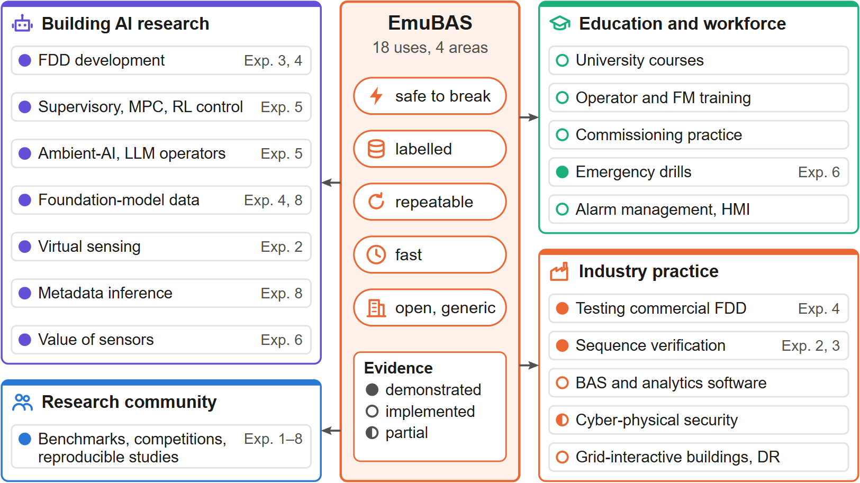
Fig. 18. Eighteen uses of EmuBAS in four areas, all following from five properties: safe to break, labelled, repeatable, fast, and open and generic. Filled dots mark uses demonstrated by the experiments of this paper (experiment numbers at right); open dots mark uses whose required functions are implemented but not evaluated here; the half-filled dot marks partial support (Appendix F).

Limitations and future work
Local loops inside EnergyPlus are ideal: set-point translation reproduces their steady state under sensor error but not their fast dynamics, hunting or valve characteristics. Duct static and loop differential pressures are surrogate models because EnergyPlus does not resolve pressure networks, and the 5-min sampling interval limits the dynamics of BAS loops. Explicit BAS control currently covers multi-zone VAV systems with water-based plants; other systems are monitored and keep native control. Fault parameters follow data-sheet-type distributions rather than calibrated field statistics, and the extended environment models and the refrigerant, flue and vibration surrogates are simplified and not calibrated against measurements; ​2ozone, NO₂, formaldehyde and glare are not modelled. The emulator does not yet speak building network protocols, and the educational and training uses have not yet been evaluated with learners. Future work includes a BACnet/IP and Modbus gateway so that commercial BAS front ends and analytics can connect unchanged, Spawn-of-EnergyPlus or Modelica inner spaces for faster local dynamics, calibrated fault statistics, multi-building portfolios, an instructor/trainee mode that withholds labels and scores diagnoses, a library of cyber-attacks on BAS protocols, and standardised benchmark tasks for LLM-based building operators.

Conclusions
EmuBAS is a real-world building automation system emulator that separates the physics (EnergyPlus, inner space) from a mathematically defined and fully labelled real world (outer space). Sensors drift, data go missing, occupants move randomly, equipment and control software fail, and the BAS acts on what it sees, so the consequences of imperfection are simulated rather than superimposed. Faults and events can be injected at run time by people and AI agents, the clock runs from real time to more than 92,000 times real time, and any EnergyPlus model can be converted. For the DOE large office the emulator reproduces native EnergyPlus within 0.5% in annual electricity with ideal sensors, produces physically consistent equipment-level fault signatures, generates labelled datasets for FDD, supports AI agents as operators, controllers and adversaries, and exposes robustness gaps and indoor-environment risks that idealised environments and standard BAS hide. The same properties—safe to break, labelled, repeatable, fast and open—make it a training simulator for students and building operators, a neutral test building for commercial analytics and a shared benchmark for the research community. The software, building models, scenarios, experiments and tutorials are openly available at https://github.com/TensorBuildLab/Virtual-BAS.

Acknowledgements
This material is based upon work supported by the National Science Foundation under Award No. 2623038. Any opinions, findings, and conclusions or recommendations expressed in this material are those of the author(s) and do not necessarily reflect the views of the National Science Foundation.
- BAS-ization details
The HVAC topology is discovered from EnergyPlus’ own connection objects (AirLoopHVAC, branches, supply paths, zone splitters, ZoneHVAC:EquipmentConnections, plant and condenser loops). Every quantity the BAS writes is bound to a dedicated Schedule:Constant (a command schedule), for example a SetpointManager:Scheduled on each AHU supply-air node and plant supply node, the fan availability schedule and the minimum-flow-fraction schedule of each VAV terminal (input method Scheduled). Because this input method changes EnergyPlus’ autosizing of reheat coils, terminals and reheat coils are first hard-sized with the values of a sizing run of the native configuration. Physical faults are hooked through FaultModel:Fouling objects whose availability and severity schedules are again command schedules. Finally, the native schedules of fans, minimum outdoor air and thermostats are extracted so that the default BAS program reproduces the native operation (Table 2). Table 3 lists the points generated per equipment type, and Fig. 19 shows the sequence of one BAS sample.
Table 2. Generic transformations of the BAS-ization procedure.
Tag | Transformation
T1 | Simulation control: sizing performed, weather-file run period only
T2 | Zone time step equal to the BAS sampling interval (default 5 min)
T3 | Run period and calendar year
T4 | File outputs removed (data are exchanged through the API)
T5 | Command binding: supply-air and plant supply temperatures, fan enable and VAV air-flow commands bound to command schedules; terminals hard-sized from native sizing
T6 | Physical fault hooks: chiller, boiler and tower fouling models with command schedules
T7 | Zone CO₂ mass balance with actuatable outdoor concentration

Table 3. BAS points generated for each equipment type (abbreviated); S standard, A advanced, N next-generation tier.
Equipment | Points
Zone | S: ZN-T, ZN-CO2, ZN-OCC (PIR), heating and cooling set points, occupant set-point adjust; A: ZN-RH, ZN-DP, illuminance, lighting level, window contact, lighting power; N: people count, mean radiant and operative temperature, PMV, PPD, PM2.5, PM10, TVOC, sound level, occupant votes and complaints, plug power; truth: occupants, daylight, infiltration, solar and internal gains
VAV box | S: DA-F, DA-F-SP, DA-T, DMPR-CMD, loop outputs, terminal mode, G36 requests, low-flow alarm; A: DMPR-POS, RHV-POS, velocity pressure; N: reheat-coil water flow and energy meter; truth: reheat load
AHU | S: SA-T, SA-F, MA-T, RA-T, OA-T, OA-F, set points, damper command, economizer enable, fan command, status, speed and power, duct static pressure, filter pressure drop, freeze-stat, smoke detector, run-hours, starts, calculated OA fraction; A: humidity and CO₂ in supply and return air, coil leaving-air temperatures, valve and damper feedback, fan current; N: coil water temperatures, flows and energy meters, coil pressure drop, fan vibration; truth: coil load, OA fraction
Chiller | S: power, status, chilled- and condenser-water temperatures, %RLA, alarm, kW/ton, run-hours, starts; A: load, evaporator and condenser flows, refrigerant saturation temperatures and pressures; truth: part-load ratio, COP
Boiler, tower, pump | S: status, supply and return temperatures, firing rate, fan and pump power, speed, approach, range, alarms; A: load, gas, flow, flue temperature, make-up water; N: pump vibration
Plant loops | Supply and return temperatures, flow, differential pressure, set points, ΔT, chilled-water tons, plant kW/ton
Weather | S: OA-T, OA-RH, degree-days; A: wet bulb, dew point, enthalpy, pressure, wind, global irradiance, outdoor illuminance, rain; N: direct and diffuse irradiance, sky cover, outdoor PM2.5 and PM10, forecasts
Meters, grid | S: building electricity and gas demand, water, totalisers, 15-min and peak demand; A: end-use sub-meters, tower make-up water; N: plug and elevator sub-meters, tariff, carbon intensity, demand-response event, cost and carbon

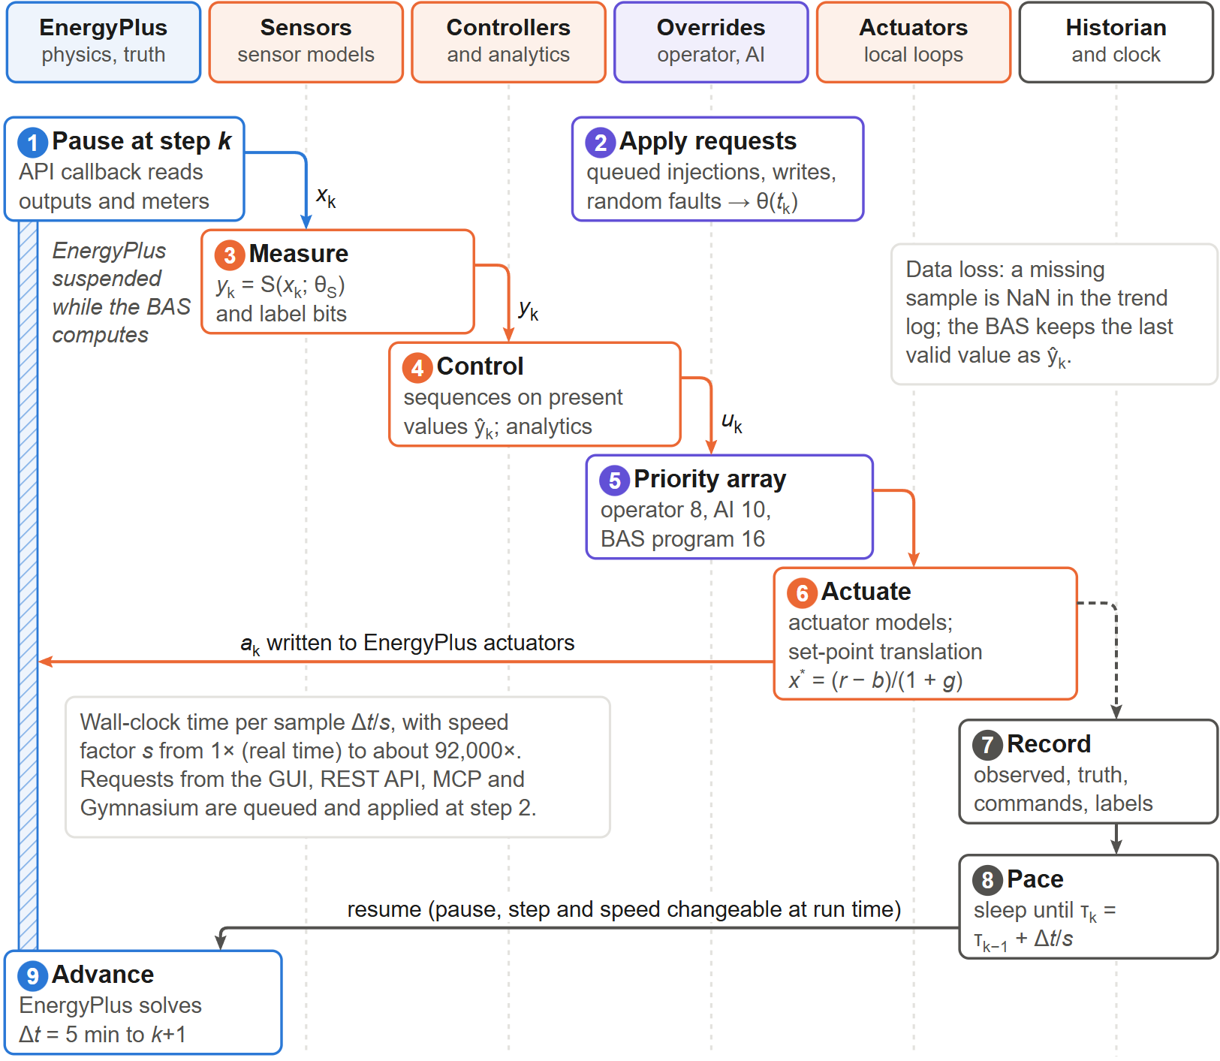

Fig. 19

. One BAS sample k (Δt = 5 min) as a sequence across the six layers of EmuBAS. EnergyPlus is suspended (hatched bar) from the API callback (1) until the clock releases it (9); in between, queued requests are applied (2), the truth is measured (3), controllers act on present values (4), overrides are resolved (5), commands are actuated with set-point translation (6), everything is recorded (7) and the wall clock is paced to the speed factor $s$ (8).
- Sensor, occupancy and environment models
Sensor model. For a physical quantity xk the recorded value is obtained in four steps:
xk =xk-1+Δtτ+Δtxk-xk-1dk =dk-1+r Δt+ϑμd-dk-1Δt+σdΔt ξkzk =(1+g) xk+b+dk+σnεk+Bkσsηkyk =clipδ round(zk/δ), y min , y max (6)
with time constant τ, drift rate r, Ornstein–Uhlenbeck parameters ϑ, μd, σd, white noise σnεk and Bernoulli spikes Bk∼Bern(ps). Missing data follow a two-state Gilbert–Elliott chain with transition probabilities pgb and pbg and stationary loss rate $p_{gb}/(p_{gb}+p_{bg})$. Binary sensors (occupancy, status) use false-on and false-off probabilities. Each sensor uses an independent random stream, so that scenarios with different faults share common random numbers. Fig. 20 illustrates the model.
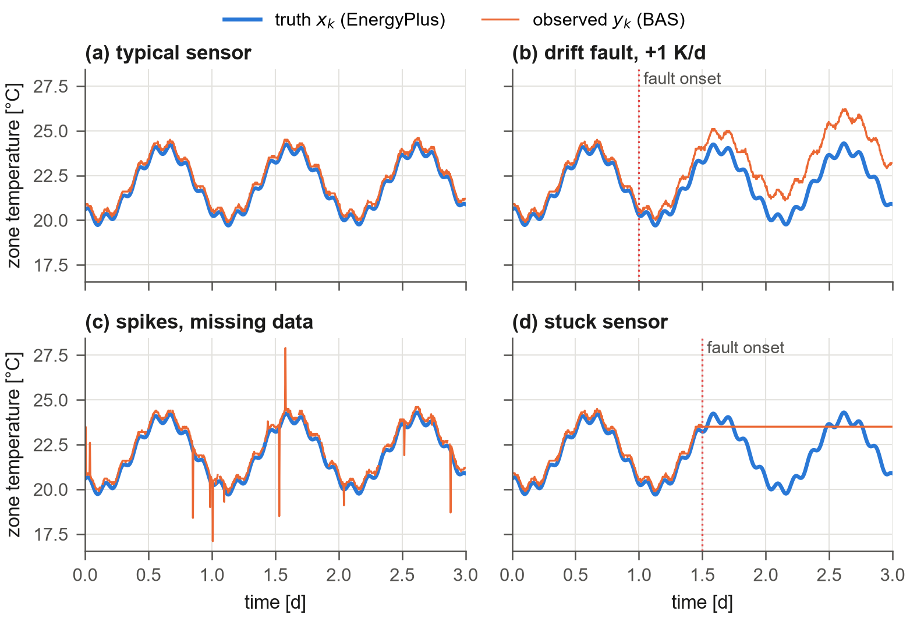
Fig. 20. Sensor model output for a zone temperature sensor: (a) typical commercial sensor, (b) drift fault, (c) spikes with bursty missing data and (d) stuck sensor, each against the EnergyPlus truth.
Occupancy. With the zone’s occupancy schedule Pk, a daily attendance factor and mobility μ, the transition probabilities of the Markov chain of Page et al. [43] are
T01=μ-1μ+1Pk+Pk+1, T11=Pk-1Pkμ-1μ+1Pk+Pk+1+Pk+1Pk (7)
and the count follows nk+1=Bin(nk,T11)+Bin(N-nk,T01) (Fig. 21).
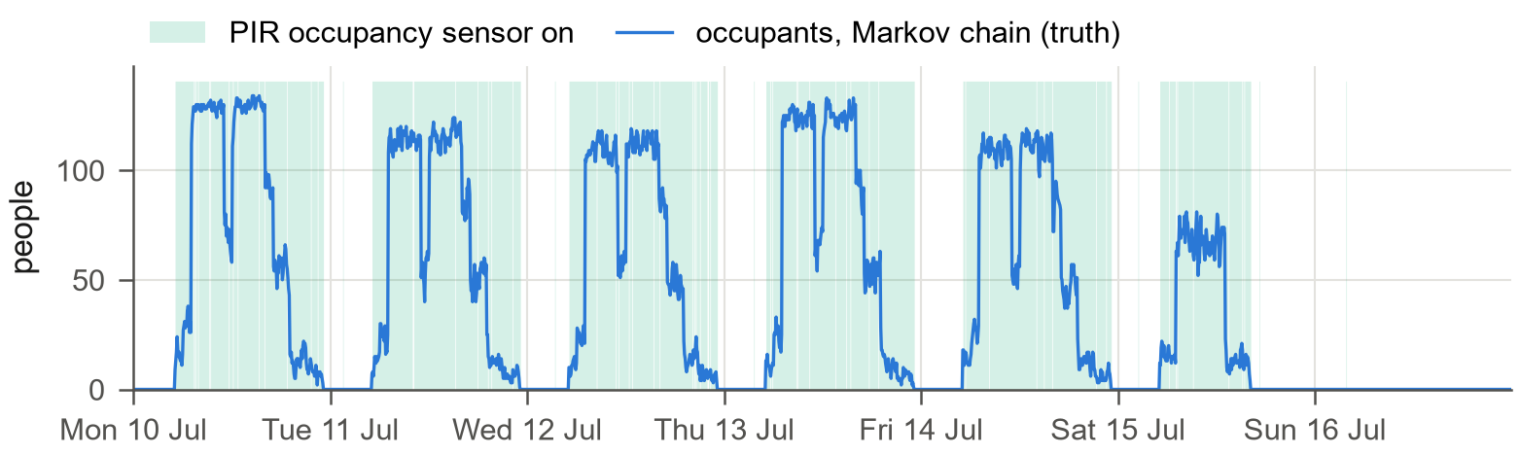
Fig. 21. Stochastic occupancy of zone Core_mid during one summer week: number of occupants drawn by the Markov chain (truth, written to the EnergyPlus People actuator) and the periods in which the zone’s PIR sensor reports occupancy. Attendance varies from day to day, and the binary sensor hides the head count.
Light, sound and comfort. Work-plane illuminance combines the lumen method for electric light and the daylight-flux method, $E=E_{d}P_{light}/P_{light,d}+K_{v}UΦ_{sol}/A$, with design illuminance $E_{d}$, luminous efficacy of daylight $K_{v}$, utilisation factor $U$ and the solar flux $Φ_{sol}$ transmitted by the zone’s windows. The sound level is the energetic sum of terminal noise following the fan law, Ld+50 log 10(V/Vmax), speech scaled by the density of talking occupants, and a background level. Mean radiant and operative temperatures and PMV and PPD [45] come from EnergyPlus. Occupants submit thermal-sensation votes round(PMV+σiε) at a Poisson rate and file hot or cold complaints at a rate proportional to N PPD.
Forecasts and grid. An hourly-issued 48-h weather forecast equals the weather file plus errors whose standard deviation grows with lead time h, $σ(h)=σ_{0}+σ_{∞}(1-e^{-h/τ})$, and that are AR(1)-correlated between issues. The grid interface provides a time-of-use tariff, a synthetic marginal carbon intensity (diurnal profile, solar dip and autoregressive noise) and demand-response events with a requested shed; cost and carbon are accumulated as KPIs (Fig. 22). The forecast root-mean-square error over 168 hourly issues reproduces the prescribed growth (0.8 K at 6 h, 1.6 K at 24 h and 2.4 K at 48 h ahead), and tariff and carbon intensity peak at different times of day, so cost-optimal and carbon-optimal operation differ.
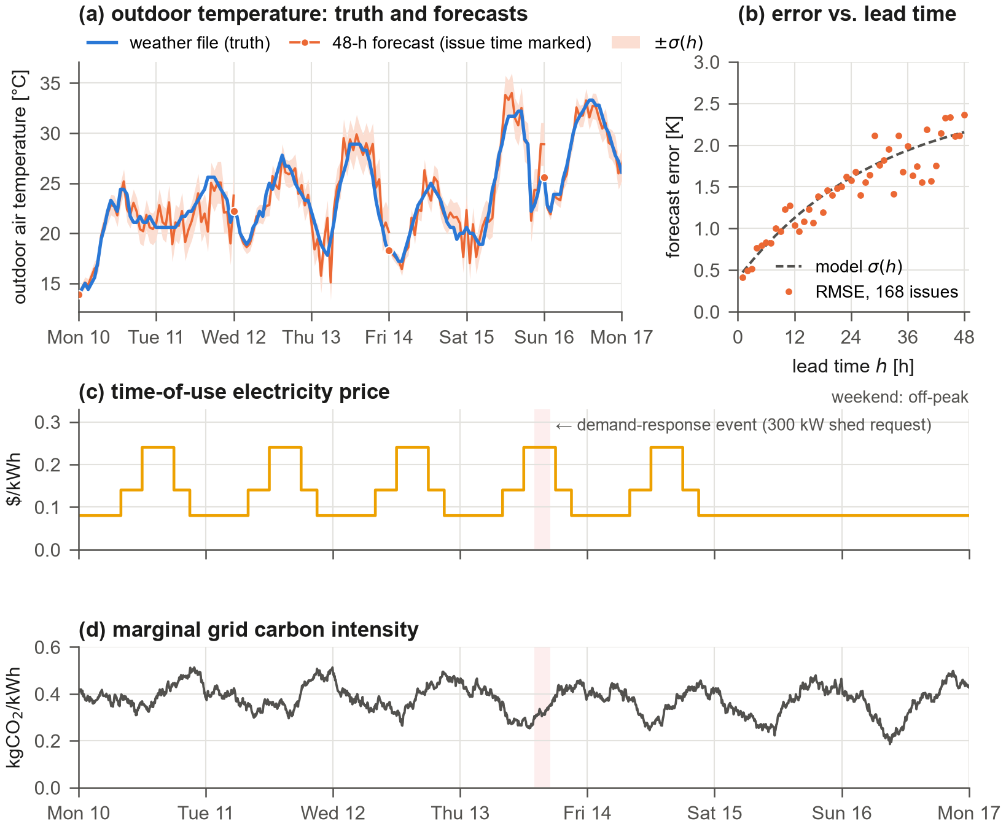
Fig. 22. Outdoor and grid signals for a July week. (a) Outdoor temperature of the weather file (truth) and 48-h forecasts issued every two days with the ±σ(h) band; (b) root-mean-square forecast error of 168 hourly issues versus lead time against the model σ(h); (c) time-of-use electricity price and (d) marginal grid carbon intensity, with a demand-response event shaded.
- BAS control program
The control program acts on present values only. It comprises occupancy scheduling and night-cycle operation; for each VAV box, cooling and heating PI loops on the zone temperature with an air-flow set point between the minimum and maximum flow (optional dual maximum); for each AHU, supply-fan start and stop, supply-air temperature set point, duct static pressure set point and an economizer with a differential dry-bulb high limit, whose outdoor-air fraction combines a mixing-equation feed-forward on the observed return and outdoor temperatures with a PI trim on the mixed-air temperature and a minimum outdoor-air limit computed from the sum of box air-flow set points; and for the plant, chilled, hot and condenser water supply temperature set points. PI controllers are discrete with anti-windup and tuned for the 5-min sampling interval. The g36 profile implements trim-and-respond resets of the supply-air temperature, duct static pressure and chilled-water temperature and an outdoor-air reset of the hot-water temperature [1]. The alarm engine uses on-delays, and the low-flow alarm of a VAV box requires the fan to be commanded on and proven and the condition to persist for 5 min.
- Labelled data products
The label bit masks mark missing samples, stuck values, spikes, active sensor faults, communication loss, false binary readings and spoofed values. Fig. 23 shows the data products for the 12-week training run of Experiment 4. The random fault generator placed 32 injections of nine types on the four AHUs (a); the label masks (b) mark every affected sample of every point, next to the background imperfections that are present without any fault (isolated missing samples, spikes, false PIR readings); and the trend of a faulty sensor can be laid over its truth with the labelled interval (c, d). A drifting mixed-air sensor departs slowly from the truth and is hard to detect, whereas a stuck supply-air sensor is obvious once the true temperature moves.
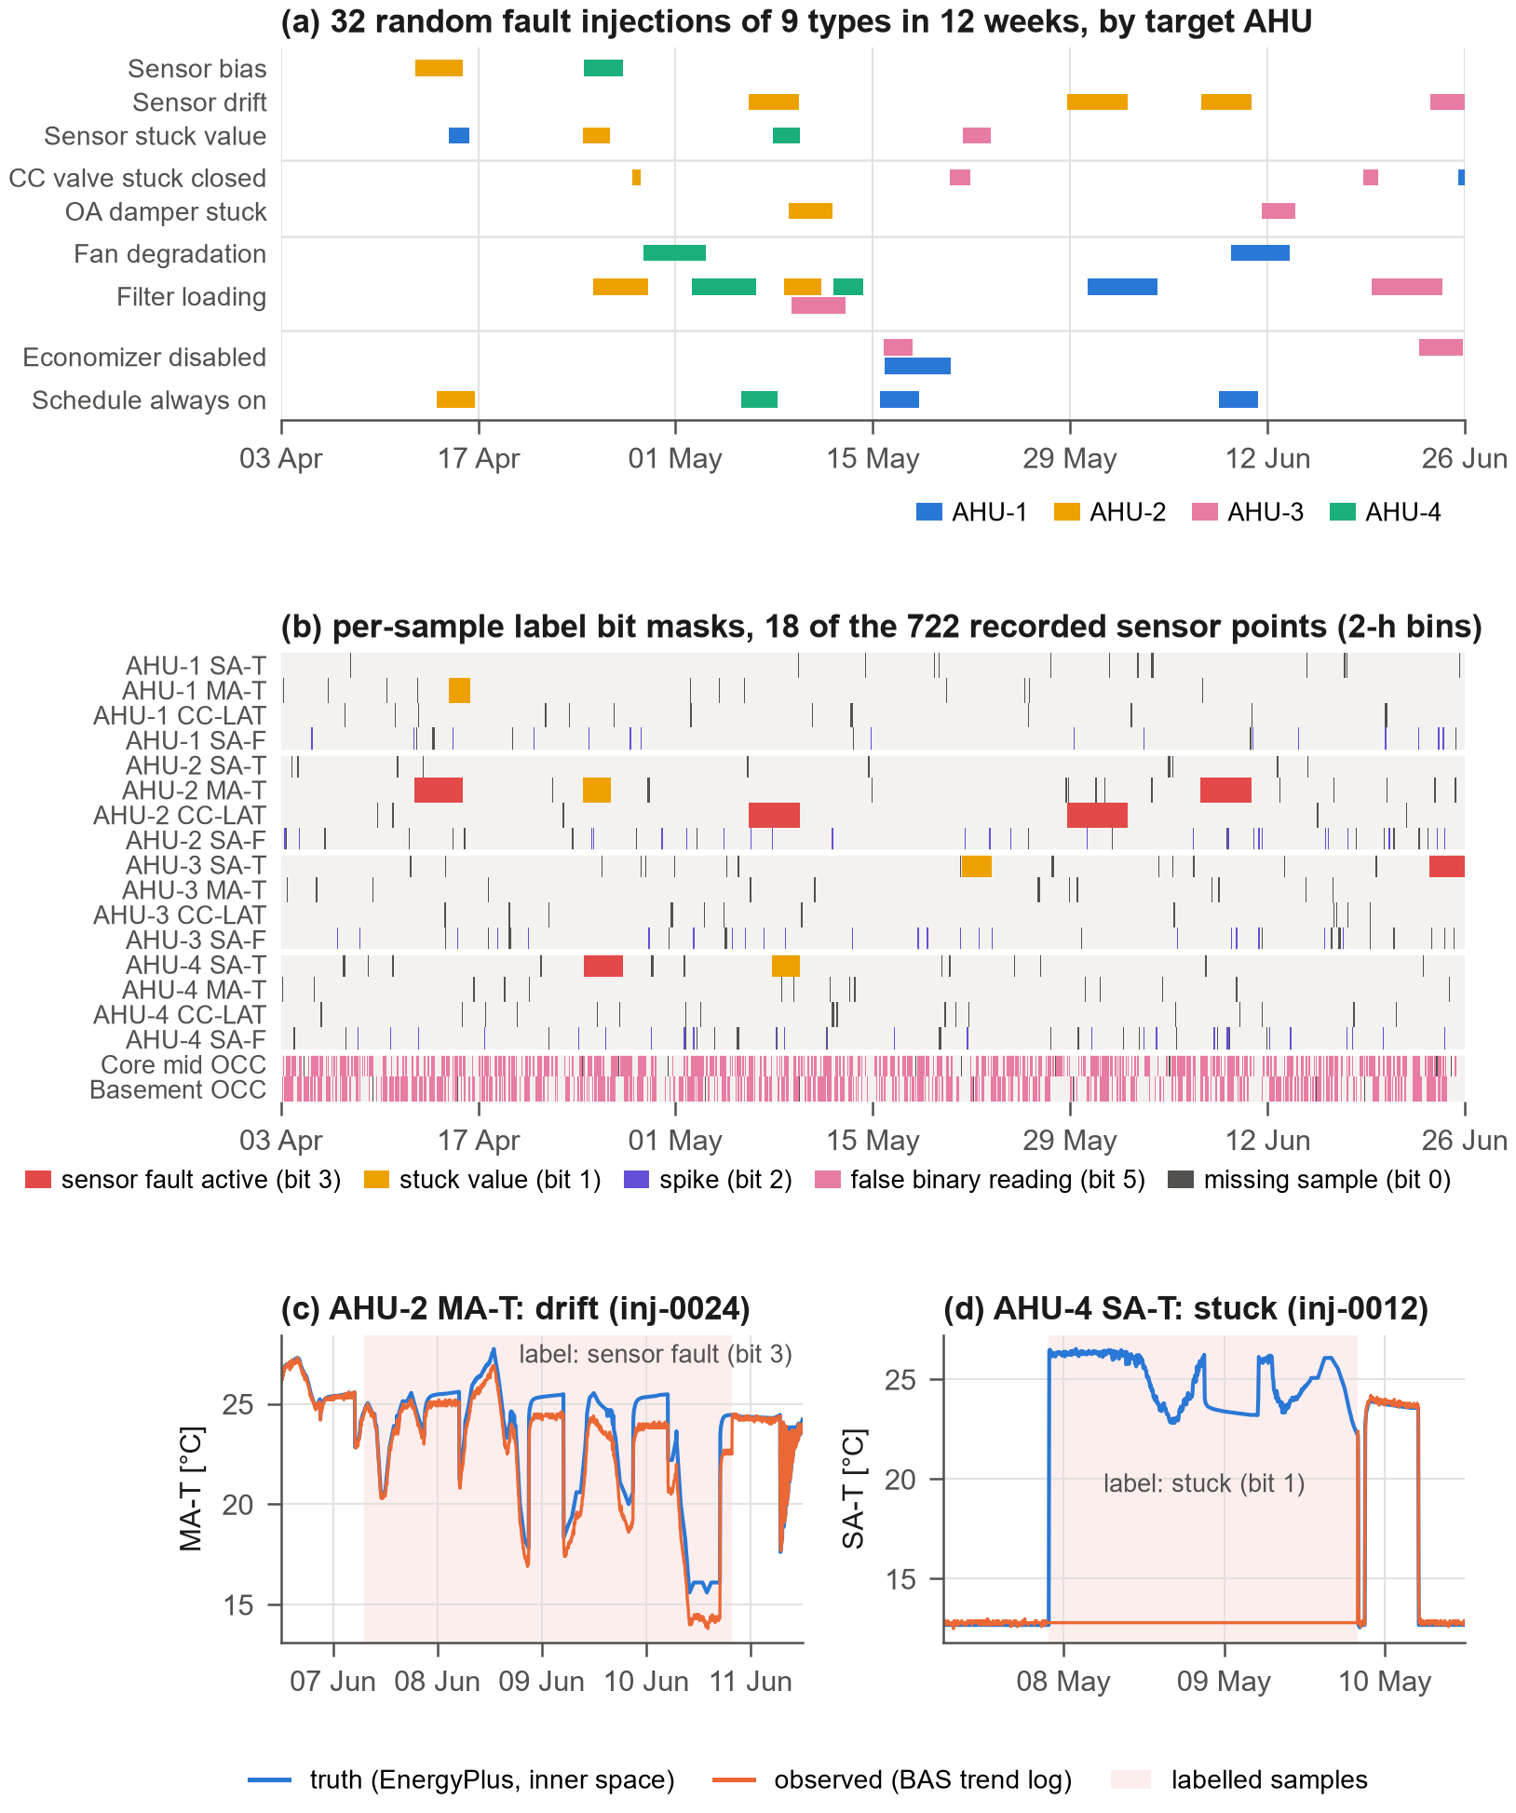
Fig. 23. Labelled data from a 12-week run with random faults (training set of Experiment 4). (a) The 32 fault injections, by type and target AHU; (b) per-sample label bit masks of 18 of the recorded sensor points (2-h bins, highest-priority bit shown); (c) drift of the AHU-2 mixed-air temperature sensor and (d) stuck AHU-4 supply-air temperature sensor: observed values and EnergyPlus truth with the labelled samples shaded.
- Additional figures
The GUI views below were taken in the same staged session as Fig. 8. Fig. 24 shows the alarm server and an operator override, Fig. 25 the fault and event injection console, Fig. 26 and Fig. 27 the indoor-environment and site pages during the smoke episode, and Fig. 28 the thermostat drift of Experiment 2 as an operator experiences it. Fig. 29 shows the pacing accuracy of Experiment 7.
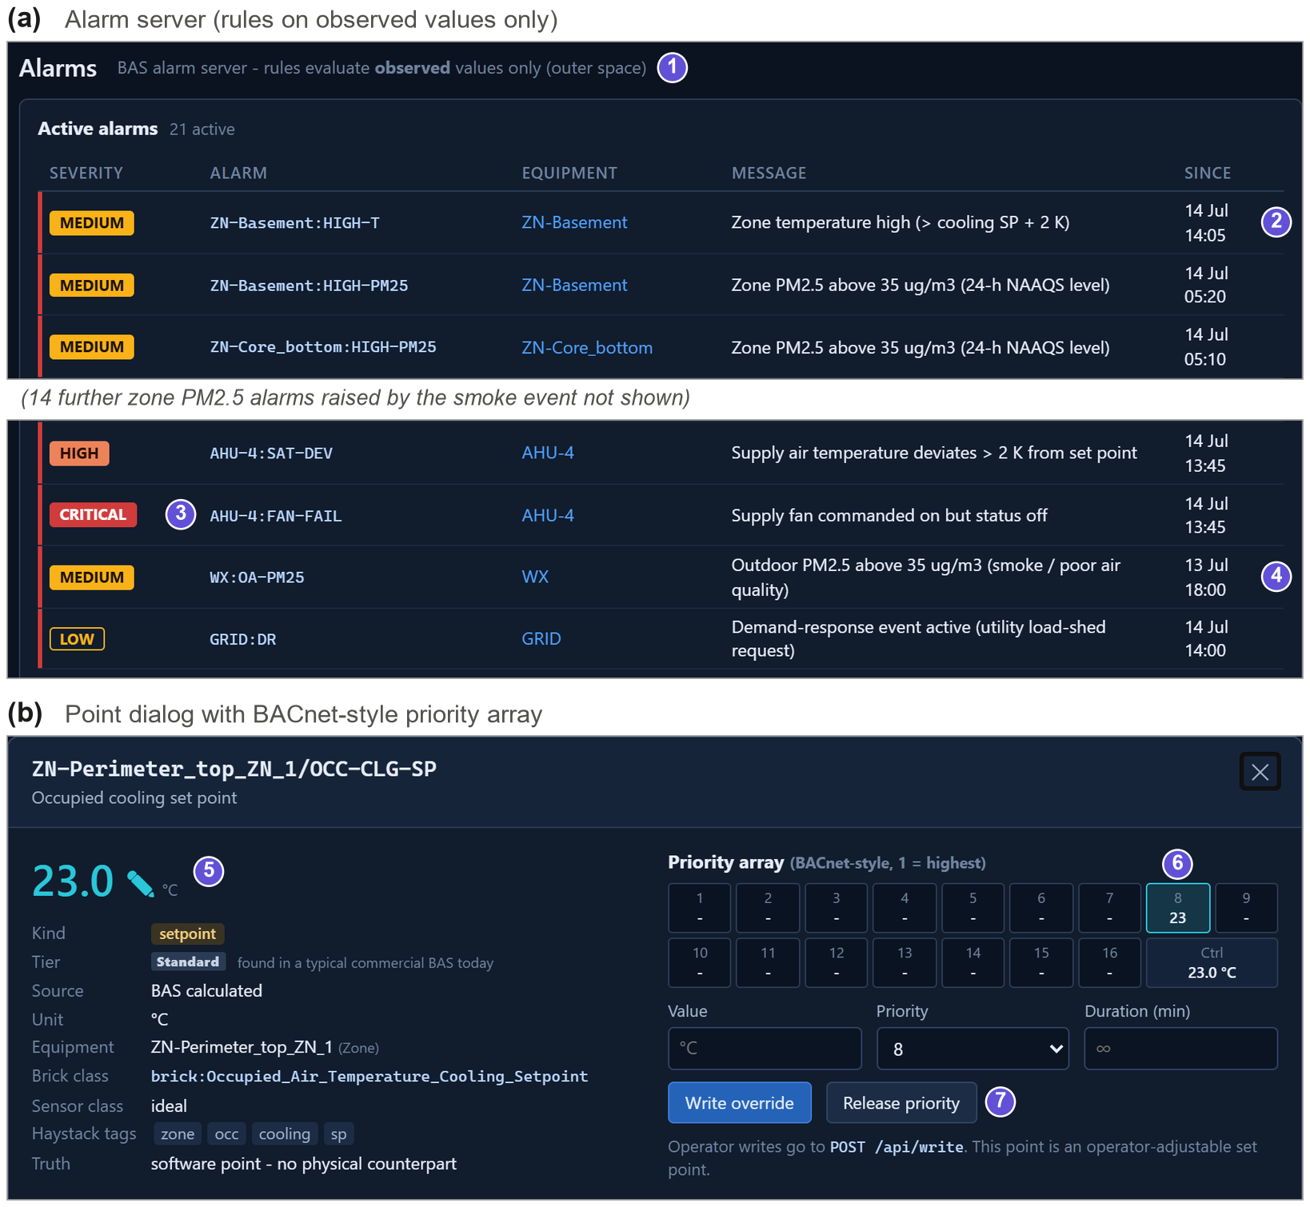
Fig. 24. Alarm server and operator override. (a) Alarm rules evaluate observed values only (1), so the injected AHU-4 fan trip raises a critical alarm (3) and a consequential high zone temperature in the basement (2), and the smoke episode raises an outdoor-air-quality alarm (4), whereas the drifting thermostat raises none. (b) Point dialog with its BACnet-like 16-level priority array: an operator write of 23 °C at priority 8 is active (6) and can be released (7).
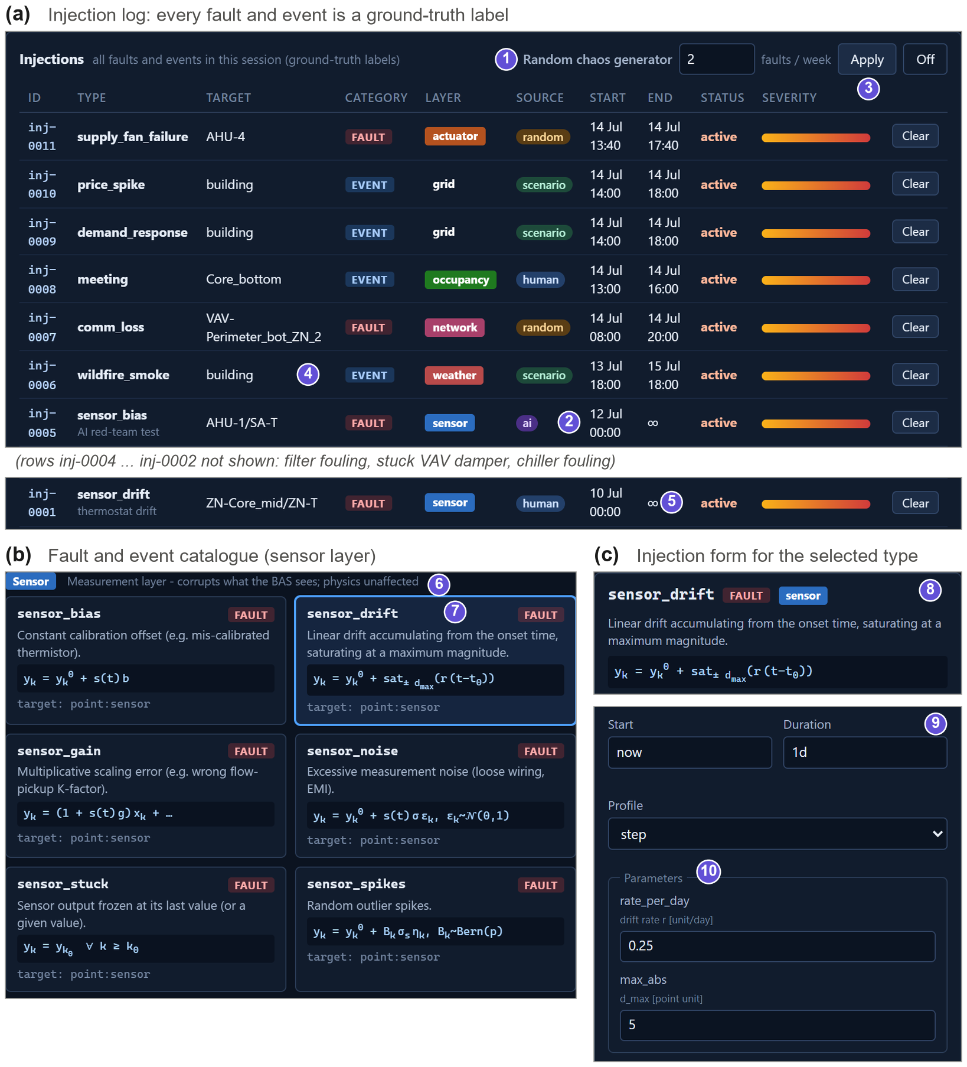
Fig. 25. Fault and event injection console. (a) Injection log: people, scenarios, the random generator (1) and AI agents (2) inject from the same catalogue, and every injection is logged with type, target, onset, end and severity profile (3) as a ground-truth label; events such as wildfire smoke are distinguished from faults (4). (b) Catalogue of the sensor layer with the defining equation of each type (6, 7). (c) Injection form generated from the parameter specification of the selected type (8–10).
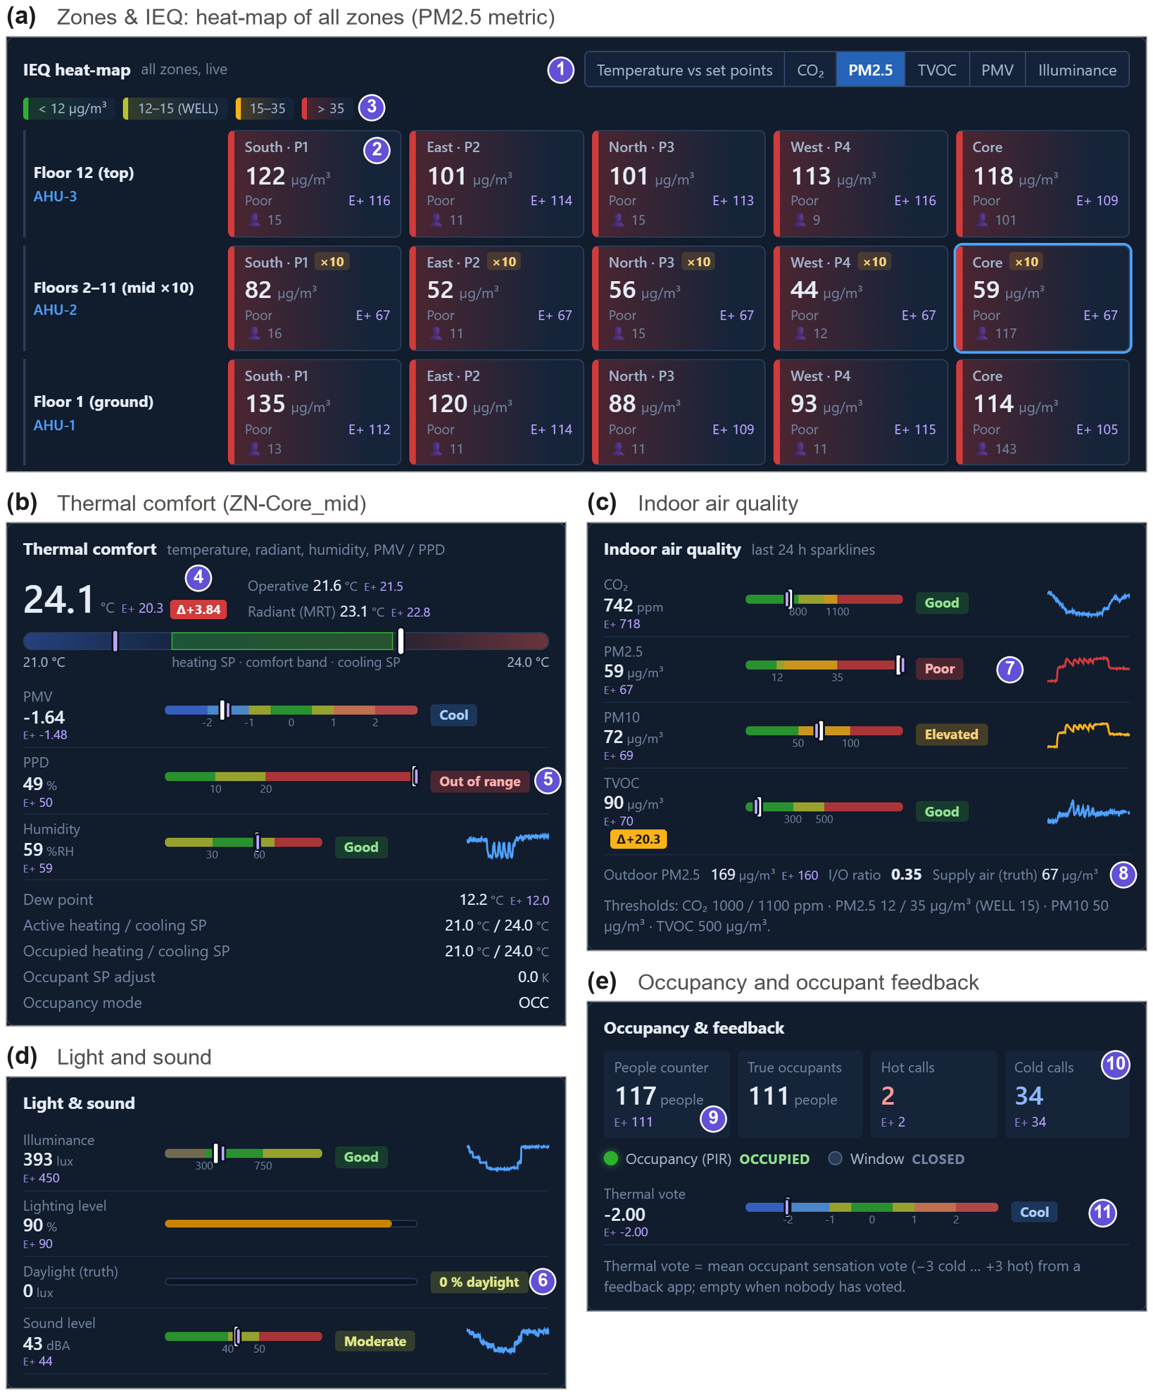
Fig. 26. Indoor-environment pages during the staged wildfire-smoke episode. (a) Building heat-map on the PM2.5 metric (1–3): every zone exceeds 35 µg/m³. (b)–(e) Zone Core_mid: thermal comfort with the drift-affected temperature (4) and a PPD of 49% (5), indoor air quality with a 24-h sparkline of the smoke onset (7) and the outdoor, indoor and supply-air concentrations (8), light and sound with the truth-only daylight share (6), and occupancy and feedback: a people counter with its own error against the true count (9), cold complaints (10) and the mean thermal-sensation vote (11).
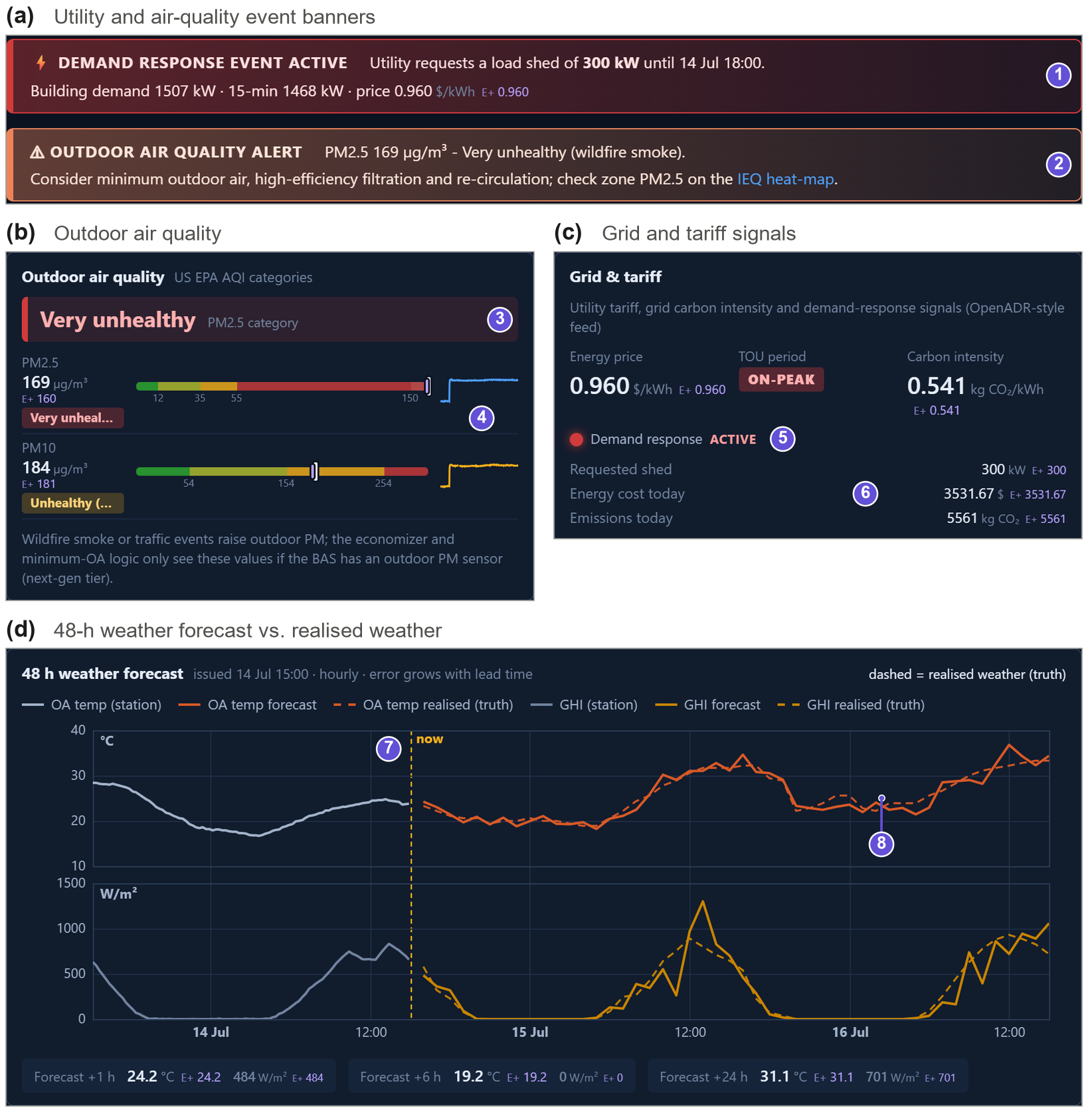
Fig. 27. Site, utility and forecast page during the staged smoke episode. (a) Event banners: a demand-response request of 300 kW (1) and an outdoor-air-quality alert with operator advice (2); (b) outdoor air quality with AQI category (3) and observed versus true PM2.5 and PM10 (4); (c) grid and tariff with the active demand-response event (5) and cost and emissions accounting (6); (d) 48-h forecast issued at the current hour (7) against the realised weather (8).
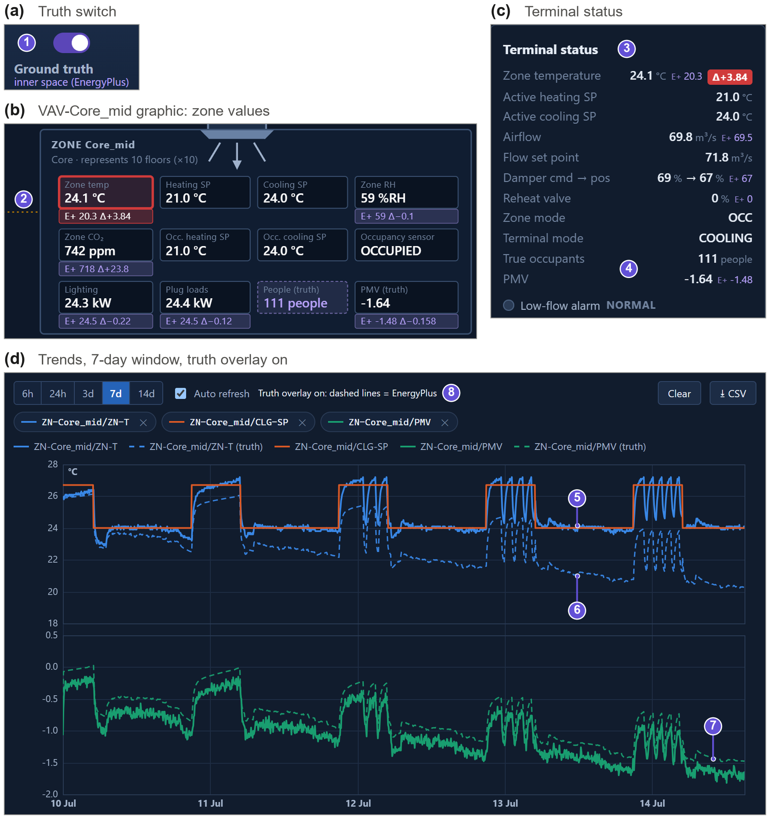
Fig. 28. The thermostat drift as seen in the GUI (staged session, 0.8 K/day from Monday 00:00). (a) Ground-truth switch (1); (b) VAV-Core_mid graphic and (c) terminal status: observed 24.1 °C against an EnergyPlus truth of 20.3 °C (2, 3), with the truth-only occupant count and PMV (4); (d) 7-day trends: the observed temperature is held at the cooling set point (5) while the truth (dashed) falls to about 20 °C (6) and PMV to about −1.6 (7).
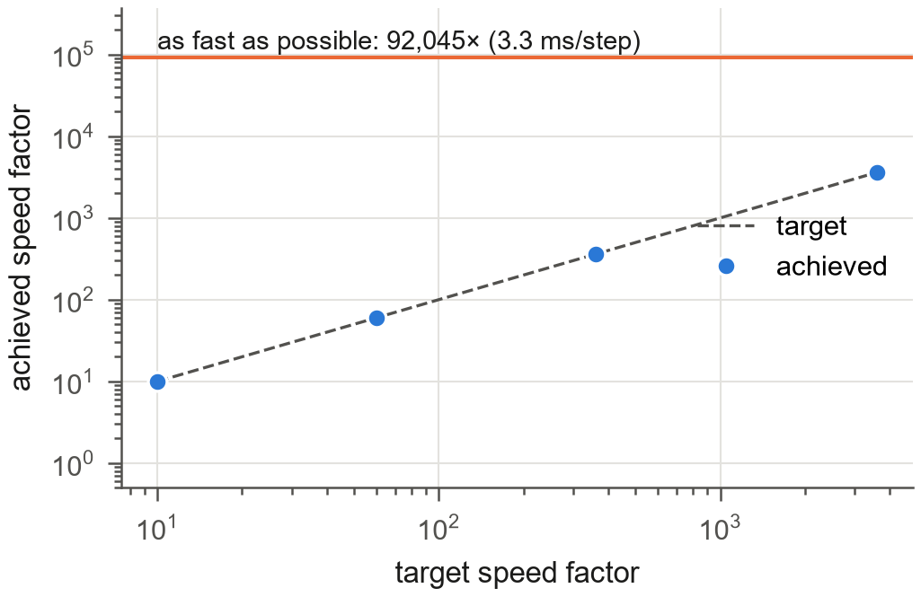
Fig. 29. Experiment 7: target versus achieved speed factor and the maximum throughput.
- Potential uses in detail
Table 4. Potential uses of EmuBAS, with primary users. Evidence: Exp. n, demonstrated in Experiment n; interfaces, all required functions are implemented but not evaluated in this paper; partial, some functions are missing.
Use (users) | What EmuBAS provides | Evidence
Research and development
FDD development and benchmarking (FDD researchers, analytics developers) | Unlimited labelled data with controlled fault type, severity, season and sensor quality; closed-loop tests | Exp. 3, 4
Control sequences, model predictive and learning-based control (control researchers) | Gymnasium and REST interfaces; sensor errors, missing data and faults; ideal versus realistic outer space on the same physics | Exp. 5
Ambient-AI and LLM operators (AI researchers, BAS vendors) | MCP tools, overrides and alarms at any speed; ground truth for scoring; agents as operators and adversaries | Exp. 5
Foundation models (machine-learning researchers) | Diverse, labelled, multivariate BAS time series for any EnergyPlus model [49] | Exp. 4, 8
Virtual sensing and sensor recalibration (researchers) | Observed and true values side by side; defined bias, drift, lag and data-loss models | Exp. 2
Metadata inference, portable applications (researchers, integrators) | Haystack and Brick point lists with known metadata for converted buildings [54] | Exp. 8
Value of information, sensor design (sensor makers, standard writers) | Standard, advanced and next-generation tiers; one scenario seen through different instrumentation | Exp. 6
Education and workforce development
University courses (instructors, students) | BAS-like GUI; equipment that can be broken safely; truth switch; open scenarios; a season in one lab session | interfaces
Operator and facility-manager training (owners, utilities, training programmes) | Drills with hidden or random faults; alarms, trends and overrides as in a real BAS; labels as answer key | interfaces
Commissioning practice (commissioning agents) | Functional tests of sequences, staged faults, trend review against known causes | interfaces
Emergency and resilience drills (facility managers) | Wildfire smoke, heat waves, cold snaps, equipment trips and demand response at run time | Exp. 6
Alarm management and interface design (human-factors researchers) | Reproducible alarm floods and faults for user studies under identical conditions [50] | interfaces
Industry practice
Testing commercial FDD and analytics (owners, efficiency programmes) | Blind test buildings with known faults and severities; scoring against labels | Exp. 4
Sequence verification, virtual commissioning (designers, contractors) | Sequences in closed loop and under sensor faults before site work [51] | Exp. 2, 3
BAS and analytics software (vendors, start-ups) | A mock building behind REST, WebSocket and MCP for integration tests and demonstrations | interfaces
Cyber-physical security (security researchers) | Spoofed readings, malicious overrides, controller and historian outages and their physical impact [52] | partial
Grid-interactive buildings (utilities, aggregators) | Tariff, carbon intensity, demand-response events and demand meters [53] | interfaces
Research community
Benchmarks, competitions, reproducibility (all) | Seeded scenarios, open building models, common KPIs and public code | Exp. 1–8

References
[1] ASHRAE, ASHRAE Guideline 36-2021: High-Performance Sequences of Operation for HVAC Systems, ASHRAE, Atlanta, GA, 2021.
[2] S. Katipamula, M.R. Brambley, Methods for fault detection, diagnostics, and prognostics for building systems–-a review, Part I, HVAC&R Research 11 (2005) 3–25.
[3] W. Kim, S. Katipamula, A review of fault detection and diagnostics methods for building systems, Science and Technology for the Built Environment 24 (2018) 3–21.
[4] Z. Wang, T. Hong, Reinforcement learning for building controls: The opportunities and challenges, Applied Energy 269 (2020) 115036. https://doi.org/10.1016/j.apenergy.2020.115036.
[5] T. Wei, Y. Wang, Q. Zhu, Deep reinforcement learning for building HVAC control, in: Proceedings of the 54th Annual Design Automation Conference (DAC '17), 2017, pp. 1–6.
[6] Z. Zhang, K.P. Lam, Practical implementation and evaluation of deep reinforcement learning control for a radiant heating system, in: Proceedings of the 5th Conference on Systems for Built Environments (BuildSys '18), 2018, pp. 148–157.
[7] L. Zhang, Z. Chen, V. Ford, Advancing building energy modeling with large language models: Exploration and case studies, Energy and Buildings 323 (2024) 114788. https://doi.org/10.1016/j.enbuild.2024.114788.
[8] L. Zhang, Z. Chen, Large language model-based interpretable machine learning control in building energy systems, Energy and Buildings 313 (2024) 114278. https://doi.org/10.1016/j.enbuild.2024.114278.
[9] K. Nweye, B. Liu, P. Stone, Z. Nagy, Real-world challenges for multi-agent reinforcement learning in grid-interactive buildings, Energy and AI 10 (2022) 100202. https://doi.org/10.1016/j.egyai.2022.100202.
[10] G. Dulac-Arnold, N. Levine, D.J. Mankowitz, J. Li, C. Paduraru, S. Gowal, T. Hester, Challenges of real-world reinforcement learning: definitions, benchmarks and analysis, Machine Learning 110 (2021) 2419–2468.
[11] G. Fierro, M. Pritoni, M. AbdelBaky, P. Raftery, T. Peffer, G. Thomson, D.E. Culler, Mortar: An Open Testbed for Portable Building Analytics, ACM Transactions on Sensor Networks 16 (2019).
[12] W.J. Fisk, D.P. Sullivan, D. Faulkner, E. Eliseeva, CO2 Monitoring for Demand Controlled Ventilation in Commercial Buildings, Lawrence Berkeley National Laboratory, 2010.
[13] International WELL Building Institute, WELL Building Standard, version 2, 2020. https://v2.wellcertified.com.
[14] E. Mills, Building commissioning: a golden opportunity for reducing energy costs and greenhouse gas emissions in the United States, Energy Efficiency 4 (2011) 145–173. https://doi.org/10.1007/s12053-011-9116-8.
[15] N. Fernandez, S. Katipamula, W. Wang, Y. Xie, M. Zhao, C. Corbin, Impacts of Commercial Building Controls on Energy Savings and Peak Load Reduction, Pacific Northwest National Laboratory, Richland, WA, 2017.
[16] American Nuclear Society, ANSI/ANS-3.5-2018 (R2024): Nuclear Power Plant Simulators for Use in Operator Training and Examination, American Nuclear Society, La Grange Park, IL, 2018.
[17] A. Dosovitskiy, G. Ros, F. Codevilla, A. Lopez, V. Koltun, CARLA: An open urban driving simulator, in: Proceedings of the 1st Annual Conference on Robot Learning (CoRL), 2017, pp. 1–16.
[18] P. Xu, P. Haves, J.J. Deringer, A simulation-based testing and training environment for building controls, in: Proceedings of SimBuild 2004, IBPSA-USA National Conference, Boulder, CO, 2004.
[19] H. Johra, L. Rohde, E. Petrova, Video game-based learning for teaching building thermodynamics and control of HVAC systems, in: Proceedings of BuildSim-Nordic 2020, Oslo, Norway, 2020.
[20] D.B. Crawley, L.K. Lawrie, F.C. Winkelmann, W.F. Buhl, Y.J. Huang, C.O. Pedersen, R.K. Strand, R.J. Liesen, D.E. Fisher, M.J. Witte, J. Glazer, EnergyPlus: creating a new-generation building energy simulation program, Energy and Buildings 33 (2001) 319–331. https://doi.org/10.1016/S0378-7788(00)00114-6.
[21] U.S. Department of Energy, EnergyPlus Python API documentation (version 23.2), 2023. https://energyplus.readthedocs.io/en/latest/api.html.
[22] Project Haystack, Project Haystack: open source initiative to streamline working with data from the Internet of Things, 2026. https://project-haystack.org.
[23] B. Balaji, A. Bhattacharya, G. Fierro, J. Gao, J. Gluck, D. Hong, A. Johansen, J. Koh, J. Ploennigs, Y. Agarwal, M. Bérges, D. Culler, R. Gupta, M.B. Kj\aergaard, M. Srivastava, K. Whitehouse, Brick: Towards a unified metadata schema for buildings, in: Proceedings of the 3rd ACM International Conference on Systems for Energy-Efficient Built Environments (BuildSys '16), 2016, pp. 41–50. https://doi.org/10.1145/2993422.2993577.
[24] Anthropic, Model Context Protocol specification, 2024. https://modelcontextprotocol.io.
[25] M. Towers, A. Kwiatkowski, J. Terry, J.U. Balis, G. De Cola, T. Deleu, M. Goulão, A. Kallinteris, M. Krimmel, A. KG, Gymnasium: A standard interface for reinforcement learning environments, arXiv:2407.17032, 2024.
[26] M. Deru, K. Field, D. Studer, K. Benne, B. Griffith, P. Torcellini, B. Liu, M. Halverson, D. Winiarski, M. Rosenberg, M. Yazdanian, J. Huang, D. Crawley, U.S. Department of Energy Commercial Reference Building Models of the National Building Stock, National Renewable Energy Laboratory, Golden, CO, 2011.
[27] M. Wetter, Co-simulation of building energy and control systems with the Building Controls Virtual Test Bed, Journal of Building Performance Simulation 4 (2011) 185–203. https://doi.org/10.1080/19401493.2010.518631.
[28] D. Blum, J. Arroyo, S. Huang, J. Drgo\vna, F. Jorissen, H.T. Walnum, Y. Chen, K. Benne, D. Vrabie, M. Wetter, L. Helsen, Building optimization testing framework (BOPTEST) for simulation-based benchmarking of control strategies in buildings, Journal of Building Performance Simulation 14 (2021) 586–610. https://doi.org/10.1080/19401493.2021.1986574.
[29] M. Wetter, W. Zuo, T.S. Nouidui, X. Pang, Modelica Buildings library, Journal of Building Performance Simulation 7 (2014) 253–270. https://doi.org/10.1080/19401493.2013.765506.
[30] T. Marzullo, S. Dey, N. Long, J. Leiva Vilaplana, G. Henze, A high-fidelity building performance simulation test bed for the development and evaluation of advanced controls, Journal of Building Performance Simulation 15 (2022) 379–397. https://doi.org/10.1080/19401493.2022.2058091.
[31] P. Scharnhorst, B. Schubnel, C. Fernández Bandera, J. Salom, P. Taddeo, M. Boegli, T. Gorecki, Y. Stauffer, A. Peppas, C. Politi, Energym: A building model library for controller benchmarking, Applied Sciences 11 (2021) 3518. https://doi.org/10.3390/app11083518.
[32] J. Jiménez-Raboso, A. Campoy-Nieves, A. Manjavacas-Lucas, J. Gómez-Romero, M. Molina-Solana, Sinergym: a building simulation and control framework for training reinforcement learning agents, in: Proceedings of the 8th ACM International Conference on Systems for Energy-Efficient Buildings, Cities, and Transportation (BuildSys '21), 2021, pp. 319–323.
[33] J.R. Vázquez-Canteli, J. Kämpf, G. Henze, Z. Nagy, CityLearn v1.0: An OpenAI Gym environment for demand response with deep reinforcement learning, in: Proceedings of the 6th ACM International Conference on Systems for Energy-Efficient Buildings, Cities, and Transportation (BuildSys '19), 2019, pp. 356–357.
[34] G. Brockman, V. Cheung, L. Pettersson, J. Schneider, J. Schulman, J. Tang, W. Zaremba, OpenAI Gym, arXiv:1606.01540, 2016.
[35] Y. Li, Z. O'Neill, A critical review of fault modeling of HVAC systems in buildings, Building Simulation 11 (2018) 953–975. https://doi.org/10.1007/s12273-018-0458-4.
[36] R. Zhang, T. Hong, Modeling of HVAC operational faults in building performance simulation, Applied Energy 202 (2017) 178–188.
[37] J. Wen, S. Li, RP-1312 – Tools for evaluating fault detection and diagnostic methods for air-handling units, ASHRAE, Atlanta, GA, 2012.
[38] J. Granderson, G. Lin, Y. Chen, A. Casillas, J. Wen, Z. Chen, P. Im, S. Huang, J. Ling, A labeled dataset for building HVAC systems operating in faulted and fault-free states, Scientific Data 10 (2023) 342. https://doi.org/10.1038/s41597-023-02197-w.
[39] Y. Chen, G. Lin, E. Crowe, J. Granderson, Development of a unified taxonomy for HVAC system faults, Energies 14 (2021) 5581. https://doi.org/10.3390/en14175581.
[40] G.E. Uhlenbeck, L.S. Ornstein, On the theory of the Brownian motion, Physical Review 36 (1930) 823–841. https://doi.org/10.1103/PhysRev.36.823.
[41] E.N. Gilbert, Capacity of a burst-noise channel, Bell System Technical Journal 39 (1960) 1253–1265. https://doi.org/10.1002/j.1538-7305.1960.tb03959.x.
[42] E.O. Elliott, Estimates of error rates for codes on burst-noise channels, Bell System Technical Journal 42 (1963) 1977–1997. https://doi.org/10.1002/j.1538-7305.1963.tb00955.x.
[43] J. Page, D. Robinson, N. Morel, J.-L. Scartezzini, A generalised stochastic model for the simulation of occupant presence, Energy and Buildings 40 (2008) 83–98.
[44] ASHRAE, ANSI/ASHRAE Standard 52.2-2017: Method of Testing General Ventilation Air-Cleaning Devices for Removal Efficiency by Particle Size, ASHRAE, Atlanta, 2017.
[45] ISO, ISO 7730:2005 Ergonomics of the thermal environment – Analytical determination and interpretation of thermal comfort using calculation of the PMV and PPD indices and local thermal comfort criteria, International Organization for Standardization, Geneva, 2005.
[46] ASHRAE, ASHRAE Guideline 14-2014: Measurement of Energy, Demand, and Water Savings, ASHRAE, Atlanta, GA, 2014.
[47] L. Breiman, Random forests, Machine Learning 45 (2001) 5–32. https://doi.org/10.1023/A:1010933404324.
[48] F. Pedregosa, G. Varoquaux, A. Gramfort, V. Michel, B. Thirion, O. Grisel, M. Blondel, P. Prettenhofer, R. Weiss, V. Dubourg, J. Vanderplas, A. Passos, D. Cournapeau, M. Brucher, M. Perrot, Duchesnay, Scikit-learn: Machine learning in Python, Journal of Machine Learning Research 12 (2011) 2825–2830.
[49] P. Emami, A. Sahu, P. Graf, BuildingsBench: A large-scale dataset of 900K buildings and benchmark for short-term load forecasting, in: Advances in Neural Information Processing Systems 36 (NeurIPS 2023), Datasets and Benchmarks Track, 2023.
[50] International Society of Automation, ANSI/ISA-18.2-2016: Management of Alarm Systems for the Process Industries, ISA, Research Triangle Park, NC, 2016.
[51] M. Wetter, P. Ehrlich, A. Gautier, M. Grahovac, P. Haves, J. Hu, A. Prakash, D. Robin, K. Zhang, OpenBuildingControl: Digitizing the control delivery from building energy modeling to specification, implementation and formal verification, Energy 238 (2022) 121501. https://doi.org/10.1016/j.energy.2021.121501.
[52] W. Granzer, F. Praus, W. Kastner, Security in building automation systems, IEEE Transactions on Industrial Electronics 57 (2010) 3622–3630. https://doi.org/10.1109/TIE.2009.2036033.
[53] M. Neukomm, V. Nubbe, R. Fares, Grid-interactive Efficient Buildings Technical Report Series: Overview of Research Challenges and Gaps, U.S. Department of Energy, Office of Energy Efficiency and Renewable Energy, Washington, DC, 2019.
[54] J. Gao, J. Ploennigs, M. Bergés, A data-driven meta-data inference framework for building automation systems, in: Proceedings of the 2nd ACM International Conference on Embedded Systems for Energy-Efficient Built Environments (BuildSys), 2015, pp. 23–32. https://doi.org/10.1145/2821650.2821670.

​2

